**MINISTRY OF EDUCATION AND TRAINING**

**FPT UNIVERSITY**

Capstone Project Document

Football Pitches Booking

|  |  |
| --- | --- |
| **Group 10** | |
| **Group Members** | Nguyễn Duy Phương – SE60761 – [phuongndse60761@fpt.edu.vn](mailto:phuongndse60761@fpt.edu.vn)  Nguyễn Hữu Hoàng Giang – SE60606 – [giangnhhse60606@fpt.edu.vn](mailto:giangnhhse60606@fpt.edu.vn)  Nguyễn Đức Thịnh – 60398 – [thinhnd60398@fpt.edu.vn](mailto:thinhnd60398@fpt.edu.vn)  Nguyễn Quốc Khánh – 60556 – [khanhnq60556@fpt.edu.vn](mailto:khanhnq60556@fpt.edu.vn) |
| **Supervisor** | Lại Đức Hùng |
| **Ext Supervisor** |  |
| **Capstone Project code** | FPB |

- Ho Chi Minh, 01/2014 –

Table of Contents

Definitions, Acronyms, and Abbreviations 4

Report No.1: Introduction 5

1.1. Overview of existing system: 5

1.2. Benefit of expected system: 5

Report No.2: Introduction 6

2.1. Initial idea of group: 6

2.2. Overview of existing system: 6

2.3. Benefit of expected system: 6

Report No.3: System Requirements Specifications (SRS) 7

3.1. User requirement specification 7

3.1.1. Guest 7

3.1.2. Member 7

3.1.3. Stadium Owner 7

3.1.4. Stadium Staff 7

3.1.5. Website Master 7

3.1.6. Website Staff 8

3.1.7. System 8

3.2. System requirement specification (Specific Requirements) 8

3.2.1. External Interface Requirements 8

3.2.2. Functional Requirements 9

3.2.3. Non-Functional Requirements 57

3.2.4. Entity Relationship Diagram 58

Report No.4: System Design Description (SDD) 59

4.1. Design Overview 59

4.2. System Architectural Design 60

4.2.1. Choice of System Architecture 60

4.2.2. Discussion of Alternative Designs 60

4.2.3. Description of System Interface 60

4.3. Component Diagram 61

4.4. Detailed Description of Components 62

4.4.1. Class Diagram 62

4.4.2. Class Diagram Explanation 63

4.5. Sequence Diagram 80

4.5.1. Create Stadium 80

4.5.2. Suggest Stadium 81

4.5.3. Delete Member Rank 81

4.5.4. Create Price Table 82

4.5.5. Create Reservation 82

4.5.6. Update Reservation 83

4.5.7. Find Available Stadium 84

4.5.8. Create Promotion 84

4.5.9. Book Field 85

4.5.10. Cancel Reservation 85

4.5.11. Find Rival 86

4.5.12. Join Match 86

4.5.13. Reference Sequence Diagrams 86

4.6. User Interface Design/ Hardware Interface Design (if any) 87

4.7. Database Design 88

4.7.1. Tables description 88

4.7.2. Advertisement 89

4.7.3. Configuration 89

4.7.4. Field 90

4.7.5. FieldPrice 90

4.7.6. JoinSystemRequest 90

4.7.7. MemberRank 91

4.7.8. Notification 91

4.7.9. Pricetable 91

4.7.10. Promotion 92

4.7.11. Punish Member 92

4.7.12. Report user 92

4.7.13. Reservation 93

4.7.14. Role 94

4.7.15. Stadium 94

4.7.16. StadiumImage 95

4.7.17. StadiumRating 95

4.7.18. StadiumReview 95

4.7.19. StadiumStaff 95

4.7.20. User 96

4.7.21. UserDistance 96

4.8. Business Intelligence Agent: Suggestion Method 96

4.8.1. Overview: 96

4.8.2. Implement: 97

4.8.3. Algorithm 98

Report No.5: System Implementation & Test (SIT) 100

5.1. Introduction 100

5.1.1. System Overview 100

5.1.2. Test Approach 100

5.2. Test Plan 100

5.2.1. Functions 100

5.2.2. Features not to be tested 100

5.3. Test Cases 101

5.3.1. Role ‘Website Master’ 101

5.3.2. Role ‘Stadium Owner’ 105

5.3.3. Role ‘Member’ 117

5.3.4. Role “StadiumStaff” 121

5.4. Reference Test Cases: 135

5.5. Checklist 135

5.5.1. Checklist validation 135

5.5.2. Submission Checklist 135

5.6. Other material (if any) 135

Report No.6: Report No.6 : System User’s Manual 135

6.1. Installation Guide 136

6.1.1. System requirements 136

6.1.2. Installation 136

6.2. User’s Guide 140

6.2.1. Website Master 140

6.2.2. Website Staff 147

6.2.3. Stadium Staff 149

6.2.4. Stadium Owner 153

6.2.5. Member 163

6.2.6. Reference Guide: 167

6.2.7. Other [Optional] 168

## Definitions, Acronyms, and Abbreviations

|  |  |  |
| --- | --- | --- |
| No. | Keyword | Definition |
| 1 | B2B2C | Stand for Business to business to customer.  In this system, first business is the organization that provides stadium owner to register their stadiums. The second business is stadium owner, who provides hire stadium service, and customer is the user, who want to hire field by this system. |
| 2 | FPB | Football Pitches Booking |
| 3 | ERD | Entity Relationship Diagram |
| 4 | API | Application Programmable Interface |
| 5 |  |  |

## Introduction

Initial idea of group:

Football Pitches Booking is a B2B2C (Business to Business to Customer) website that allows customers to book field online. Besides it helps the stadium owners with advertising football stadiums and managing reservation. In addition, the website enables its admin to manage customers and stadiums.

In this situation, the Website Master is the first “Business” who provides market. And the stadium owners are the second “Business” who provide service.

### Overview of existing system:

For customers: existing systems just provide customers with address and contact information of stadiums, then customers have to contact the stadium owners to make a reservation. They have to call each stadium owner individually to check whether the field is available or not. Moreover, the current systems do not have either functions to make statistics of customers' habits or some smart functions like offering options/suggestion to customers, which is time-consuming and inconvenient to customers.

For the stadium owners, sometimes they make mistakes in management such as duplicate reservation, which leads to bad result: they could lose their customers as well as profit. When the management is executed manually and the players want to find a friendly match, the stadium owners have to help them by calling other players to arrange a game.

For the website masters, the shortage of functions of the website is the obstacle to persuade stadium owners to pay for the services.

### Benefit of expected system:

Football Pitches Booking makes the reservation easier and saves time for customers. Once they have booked, they don’t have to worry there will be a duplicate reservation caused by stadium owners' mistake. The website's smart functions help users to find the appropriate field by searching stadiums nearby their address, stadiums which are frequently booked, and the stadiums which are on discount. The benefits to customers are saving time, getting more information and enjoying discount of stadiums, beside that players find rivals easily if they do not have enough players to create a game.

This system helps stadium owners to manage their fields easily, reducing the implementing process of business operations, saving time and costs. The automatic system helps to prevent the risk of duplicate booking. Furthermore, stadium owners can use the website as a channel to advertise their services as well as communicate with their customers; hence, they can win more customers and gain more prestige through rating-feedback functions.

For the website master, with many smart and outstanding functions of the new system, they have more chances to increase the profit by attracting stadium owners to use this service.

## Project Management Plan (PMP)

### Problem Definition

#### Name of this CapStone Project.

This Capstone Project’s name is “Football Pitches Booking” or “FPB” in short.

#### Problem Abstract

Ho Chi Minh City (HCMC for short), which has population of over seven million people, is a commercial centre of Vietnam and the country’s biggest city by far despite not being the administrative capital. HCMC is a youthful city, a large number of its residents are students and clerical workers. Living in a busy city, they still take their free time to play sports for their health and their relaxation. One of the most popular sport is football. Nowadays more and more spontaneous football games are opened, so the number of artificial grass fields increases faster. Based on the latest report, there are more than one hundred stadiums in 2012, including five, seven and eleven-man field. The quantity of stadiums around HCMC also increases constantly.

Despite the high demand of hiring field, almost stadium owners still manage their stadiums manually. Players used to contact stadium owners to book field by phone, and some problems happened. They had to call the stadium owners to ask for an available booking time, sometimes the manager’s mistake created the duplicate reservation. This process has been wasting time and causing inconvenience to all involved people.   
There are some websites allowing players to search stadium and book it, but they still have limitation. Players have to wait for confirmation of stadium owners after they have checked this booking time. Managers still arrange reservation manually and mistakes still happen.

To meet that demand, we develop a website that allows users to book fields online. They can find an appropriate field based on booking time, location or field type. Some automatic functions will help them to save time like customer habits statistics. Promotion function helps stadium owners to attract their customers. Obviously players take more advantages when they register this system.  
In summary, Football Pitches Booking is developed for serving customers, stadium owners and so website administrators. It makes the reservation become easy, helps service providers manage precisely and supports business efficiently.

#### Project Overview

##### The Current Systems

According to our research, there has never been a Football pitches booking online system like the one we are developing. There are some websites that provide stadiums’ information. We divide it into two types: single stadium service (Website for one stadium owner) and multiple stadium service (Website for more than one stadium owner).

Single stadium service:

There are some services applied for one stadium. For example: <http://tuyensonsport.vn>; <http://sanbongdamini.seonhatnghe.com>

* Users just book field belonging to this stadium. The way to book is to call stadium owner.
* It is easy to make mistake in management when executing manually such as duplicate reservation.

Multiple stadium service:

* Some websites collect stadiums and provide information to users and they must contact stadium owners then. They have to call each stadium owner individually to check whether the field is available or not.
* Some websites have the booking online system, for example: http://datsan.com.vn.  
  Datsan.com.vn is a website that allows users to pick a field and book it online. This website provides searching function to make it more convenient for users. Firstly, users have to choose field, then they fill in the booking form; one point of this form that must be noticed is the booking time. After that, they must wait for the confirmation of stadium owner.    
  Maybe the booking time that user booked is not available. So when the stadium owner calls back, user must change the booking time. It really wastes time and causes inconvenience to both customers and service providers.

##### The Proposed System

The system that needs to be established should have these abilities:

* The website must have more categories that are built on the basis of districts,  types of field etc. to make it more convenient for users.
* The website has "search stadium" function. Information can be searched based on location, booking time, type of field (5, 7 or 11 men field). In addition, it should have some auto functions such as suggesting appropriate stadium based on customer habits.
* Management function for stadium owners to manage their fields, arrange booking time manually if necessary.
* Promotion function to attract customers.
* The website enables players to create matches to challenge other players.

##### Boundaries of the System :

* Website focuses about booking field for player, managing stadium for stadium owner
* Website does not intervene about finance problem of stadium owner.

##### Development Environment:

**Hardware requirements:**

* + A computerwith hardware that capable of running Windows 7 operating system, 2GB of RAM for addition software

**Sotfware requirements:**

* + Operating System : Windows 7 Professional (32 or 64 bit).

### Project organization

#### System Process Model

The software will be developed by using waterfall model. The waterfall model developing process includes five main phases:



Figure 1: Waterfall model

* + - Requirement analysis and software definition: The first phase is also the most important phase of the process which may cause great effect to other phases. This phase includes gathering requirements from customer, or from other source like the Internet, and producing the most detail and accurate software definition.
    - System design: This phase is fundamental for implementation phase. Based on customer’s requirements to create logical modules, and definite their inter relations. Using algorithm and diagram to describe implementation of those modules.
    - System implementation and Unit testing: Developing software modules follow detail designs, and doing unit testing for each module.
    - Integration and System testing: Testing output, performance in modules integrating process, and retests all functions of whole system.
    - System deployment and maintenance: After testing completely, the software is handle over client, developing team will respond for maintenance of the system.

#### Roles and Responsibilities

|  |  |  |
| --- | --- | --- |
| Full Name | Role | Responsibilities |
| Lại Đức Hùng | Supervisor, Project Manager | * Tracking and managing process * Advising ideas and solutions * Specify requirement |
| Nguyễn Duy Phương | Team Leader, Business Analyst, Developer, Tester | * Tracking and managing process * Analyzing requirement * Writing documents and reports * Designing database * Creating and managing project’s structure * Creating and managing project configuration * Creating project’s plan * Designing GUI * Coding and testing |
| Nguyễn Hữu Hoàng Giang | Team Member, Business Analyst, Developer, Tester | * Analyzing requirement * Writing documents and reports * Designing database * Designing GUI * Coding and testing |
| Nguyễn Đức Thịnh | Team Member, Business Analyst, Developer, Tester | * Analyzing requirement * Writing documents and reports * Designing database * Designing GUI * Coding and testing |
| Nguyễn Quốc Khánh | Team Member, Business Analyst, Developer, Tester | * Analyzing requirement * Writing documents and reports * Designing database * Designing GUI * Coding and testing |

#### Tools and Techniques

##### Tools

* Visual Studio 2012
* Microsoft SQL Server 2008 R2
* Star UML 5.0
* Microsoft Office 2013
* Tortoise SVN
* Google Code

##### Techniques

* .NET Framework 4.0
* ASP.NET MVC 4
* UML Modeling 2.0
* HTML5, CSS3, jQuery
* LINQ

### Project management plan

#### Tasks:

##### Study requirement and review technology

|  |  |
| --- | --- |
| Description | Discussing with project manager to understand requirement, business process.  Self-review the technology will be used in project. |
| Deliverables | N/A |
| Resources Needed | 12 man-days |
| Dependencies and Constraints | N/A |
| Risks | Requirement too strange to develop.  The project is not feasible.  The chosen technology is not feasible. |

##### Project Introduction

|  |  |
| --- | --- |
| Description | From requirements and result of researching old system create project introduction document. |
| Deliverables | Project Introduction document. |
| Resources Needed | 4 man-days |
| Dependencies and Constraints | Depend on result of studying requirement. |
| Risks | Lack of experience in researching old system  Do not understand requirements clearly. |

##### Project Management Plan

|  |  |
| --- | --- |
| Description | Prepare project plan and task list. |
| Deliverables | Project Management Plan (PMP) document. |
| Resources Needed | 4 man-days |
| Dependencies and Constraints | Depend on result of studying requirement. |
| Risks | Lack of experience in scheduling may lead to fail in keeping deadline. |

##### System Requirement Specification

|  |  |
| --- | --- |
| Description | Specify system requirements |
| Deliverables | System Requirement Specification (SRS) document |
| Resources Needed | 28 man-days |
| Dependencies and Constraints | Depend on result of studying requirement.  Follow the SRS Template.  Keeping the deadline in plan. |
| Risks | Do not understand requirements clearly. |

##### System Design Description

|  |  |
| --- | --- |
| Description | Design system architecture, describe system component, user interface design, database in details level for developer. |
| Deliverables | System Design Description (SDD) document |
| Resources Needed | 38 man-days |
| Dependencies and Constraints | Clear requirements of system.  Follow design documents template. |
| Risks | Lack of experience in system designing.  Do not understand requirements clearly.  Requirement change quickly. |

##### System Implementation and Testing

|  |  |
| --- | --- |
| Description | Implement System follow System Design Description document.  Execute unit testing.  Integrate all parts into complete system.  Integration test and system test. |
| Deliverables | Source code.  Unit test document. |
| Resources Needed | 111 man-days |
| Dependencies and Constraints | Follow SDD.  Keeping schedule. |
| Risks | Developers may not misunderstand the design.  Testers are not experience in testing.  Lack of experience in integration.  Resources cannot keeping schedule. |

##### System User’s Manual

|  |  |
| --- | --- |
| Description | Prepare guide document for users. |
| Deliverables | System User’s Manual document. |
| Resources Needed | 6 man-days |
| Dependencies and Constraints | Depend on SDD document.  The guide must easy to understand. |
| Risks | User may not understand the guide |

#### Task Sheet: Assignments and Timetable

Reference to “Football Pitches Booking.mpp” in same folder.

### Convention Rules

Reference to Microsoft C# Programming Guide – C# Coding Conventions.

<http://msdn.microsoft.com/en-us/library/vstudio/ff926074.aspx>

### Other material

N/A.

## System Design Description (SDD)

### Design Overview

* This document describes the technical and UI design of the FPB system. It includes the architectural design and the detailed design of common functions and business functions. It also includes the design of database model.
* The architectural design describes the overall architecture of the system, and the architecture of each main component and subsystem. It will describe the patterns being used, the role of each component and the role of the system in the working environment.
* The detailed design describes static and dynamic structure for each component and function. It includes class diagrams, class explanations, and sequence diagrams of the main use cases. The detailed design uses notations of .NET framework 4.0 and C#, as they are the framework and language for developing this system.
* The database design describes the relationship between entities, and details of each entity. It uses notations of SQL Server 2008 R2 as it is the database server for developing the system.
* The user interface design describes the layout of the system, and some design for the screens

### System Architectural Design

#### Choice of System Architecture

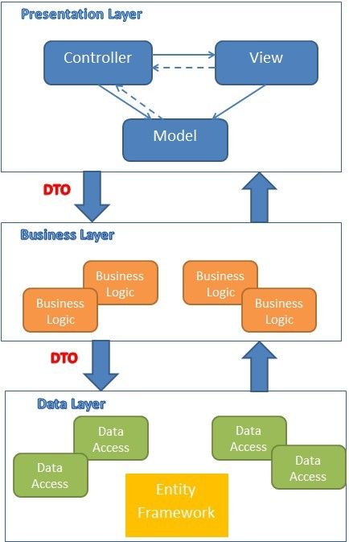

Figure 36: MVC implemented in a three-layer architecture

The above diagram is explained as the following:

**Model**: Used to prepare data for view

**View**: The view displays the data and also takes input form user. It renders the model data into a form, such as graphics, buttons, and tables, and so on to display to the user.

**Controller:** The controller handles all requests coming from the view or user interface. The data flows to whole application are controlled by controller.

**Business Logic:** This layer coordinates the application, processes commands, makes logical decisions and evaluations, and performs calculations. It also moves and processes data between the two surrounding layers.

**Data Access:** Here information is stored and retrieved from a database or file system. The information is then passed back to the logic tier for processing, and then eventually back to the user.

#### Discussion of Alternative Designs

N/A

#### Description of System Interface

N/A

### Component Diagram

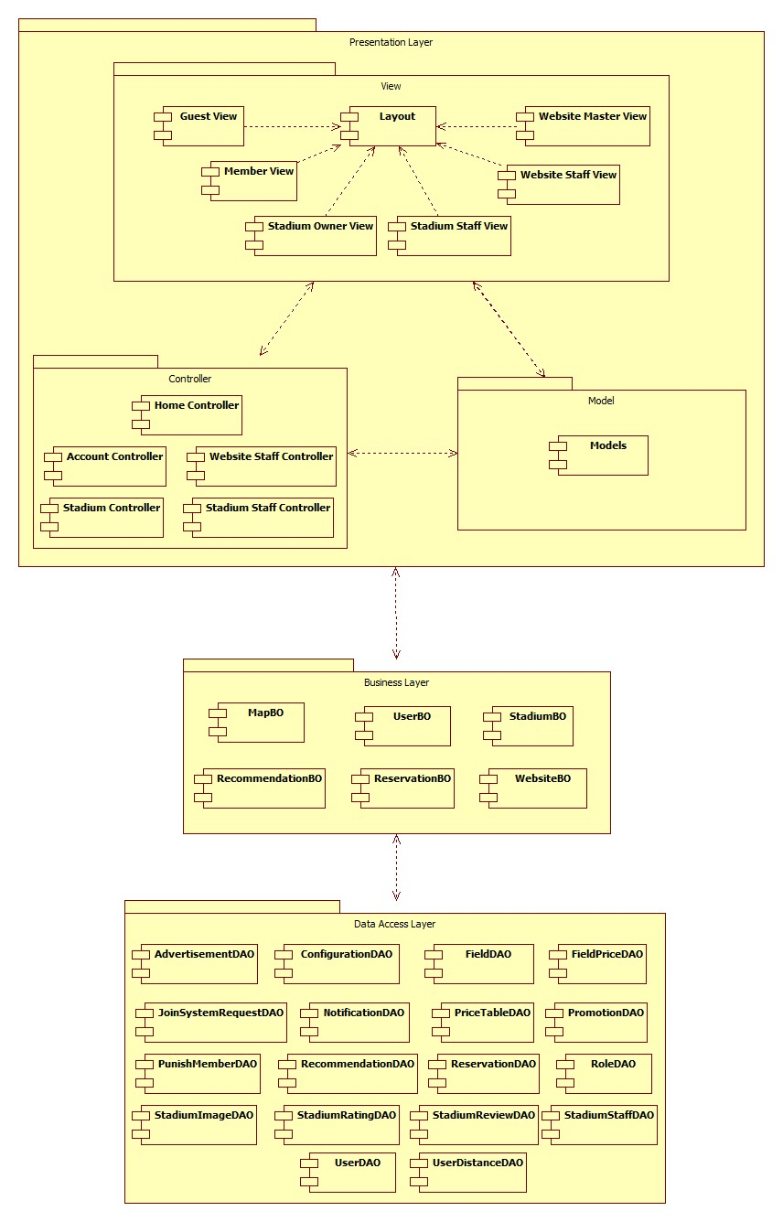

Figure 37: Component Diagram

### Detailed Description of Components

#### Class Diagram

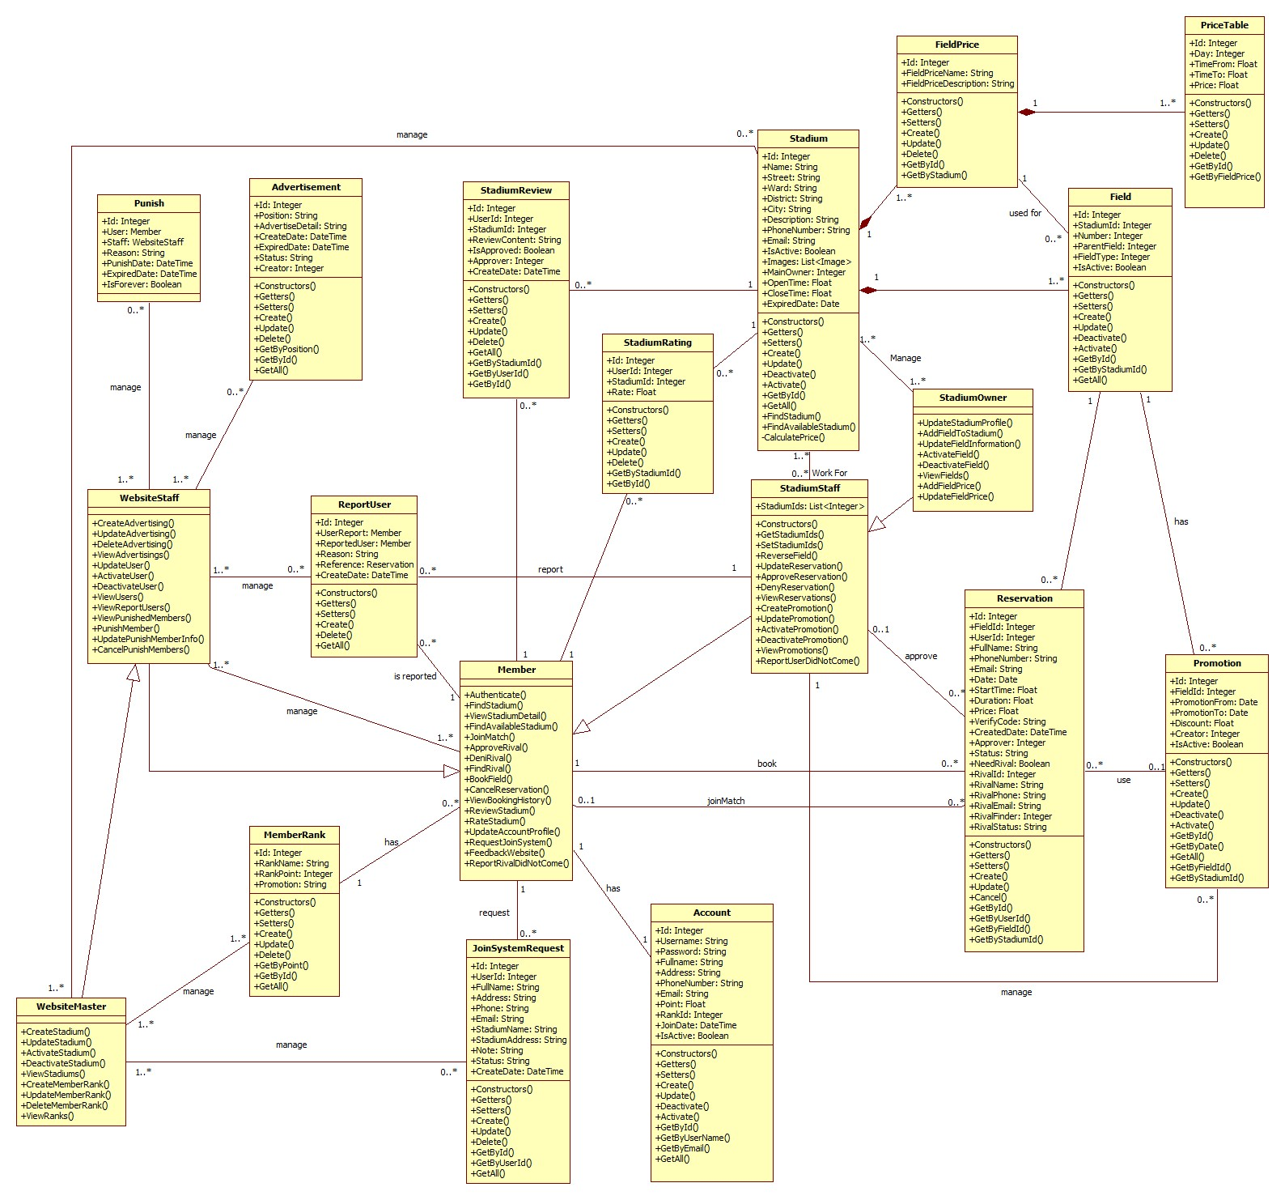

Figure 38: General Class Diagram

#### Class Diagram Explanation

##### Role

* **Attributes**

|  |  |  |
| --- | --- | --- |
| **Name** | **Type** | **Description** |
| Id | Integer | Id of Role |
| Role | String | Role |
| DisplayName | String | Display name of Role |

* **Methods**

|  |  |  |  |
| --- | --- | --- | --- |
| **Name** | **Parameter** | **Return Type** | **Description** |
| Constructors | Optional | Account | Initialize a role with value (optional) |
| Getters | N/A | Type of attribute | Get value of an attribute corresponding with getter of attribute |
| Setters | Value of attribute | Void | Set value for an attribute corresponding with setter of attribute |
| Create | All of attribute of class Role | Integer | Create a role and save it to database |
| Update | * Role | Integer | Update information of an existing role in database |

##### Account

* **Attributes**

|  |  |  |
| --- | --- | --- |
| **Name** | **Type** | **Description** |
| Id | Integer | Id of an user in system |
| Username | String | Name of account, it is unique in system |
| Password | String | Password of account |
| FullName | String | Full name of user |
| Address | String | Address of user |
| PhoneNumber | String | Phone number of user |
| Email | String | Email of user |
| Point | Float | Point of user, it is used to calculate rank of account |
| RankId | Integer | Rank of account |
| JoinDate | Date | The date when user join this system |
| IsActive | Boolean | Is this account active |
| Role | Integer | Id of role |

* **Methods**

|  |  |  |  |
| --- | --- | --- | --- |
| **Name** | **Parameter** | **Return Type** | **Description** |
| Constructors | Optional | Account | Initialize an account with value (optional) |
| Getters | N/A | Type of attribute | Get value of an attribute corresponding with getter of attribute |
| Setters | Value of attribute | Void | Set value for an attribute corresponding with setter of attribute |
| Create | All of attribute of class Account | Integer | Create an account and save it to database |
| Update | * Password * FullName * Address * PhoneNumber * Email * Point * RankId * Role | Integer | Update information of an existing account in database |
| Deactivate | N/A | Integer | De-active an account |
| Activate | N/A | Integer | Activate an account |
| GetById | * Id | Account | Get an account instance by Id of account from database |
| GetByUserName | * UserName | Account | Get an account instance by UserName of account from database |
| GetByEmail | * Email | Account | Get an account instance by Email of account from database |
| GetAll | N/A | List<Account> | Get all account from database |

##### Stadium

* **Attributes**

|  |  |  |
| --- | --- | --- |
| **Name** | **Type** | **Description** |
| Id | Integer | Id of stadium |
| Name | String | Name of stadium |
| Street | String | Name of street that stadium located |
| Ward | String | Name of ward that stadium located |
| District | String | Name of district that stadium located |
| City | String | Name of city or province that stadium located |
| Description | String | Description of stadium |
| PhoneNumber | String | Phone number of stadium |
| Email | String | Email of stadium |
| IsActive | Boolean | Is the stadium active |
| MainOwner | Integer | Main owner of stadium |
| OpenTime | Float | Open time of stadium |
| CloseTime | Float | Close time of stadium |
| ExpiredDate | Date | Expired date of stadium |

* **Methods**

|  |  |  |  |
| --- | --- | --- | --- |
| **Name** | **Parameter** | **Return Type** | **Description** |
| Constructors | Optional | Stadium | Initialize an Stadium with value (optional) |
| Getters | N/A | Type of attribute | Get value of an attribute corresponding with getter of attribute |
| Setters | Value of attribute | Void | Set value for an attribute corresponding with setter of attribute |
| Create | All of attribute of class Stadium | Integer | Create a stadium and save it to database |
| Update | * Name * Street * Ward * District * City * Description * PhoneNumber * Email * MainOwner * OpenTime * CloseTime * ExpiredDate | Integer | Update information of an existing stadium in database |
| Deactivate | N/A | Integer | De-active a stadium |
| Activate | N/A | Integer | Activate a stadium |
| GetById | * Id | Stadium | Get an stadium instance by Id of stadium from database |
| GetAll | N/A | List<Stadium> | Get all account from database |
| FindStadium | * Name * Address * FieldType | List<Stadium> | Get all stadiums correspond with filter |
| FindAvailable  Stadium | * Address * FieldType * Date * StartTime * Duration | List<Stadium> | Get all stadiums those are available with request date, time, location |

##### Field

* **Attributes**

|  |  |  |
| --- | --- | --- |
| **Name** | **Type** | **Description** |
| Id | Integer | Id of field |
| StadiumId | Integer | Id of stadium that contain this field |
| Number | Integer | Number of field in stadium |
| ParentField | Integer | Id of another field that contain this field |
| FieldType | Integer | Type of field |
| IsActive | Boolean | Is this field active |
| PriceId | Integer | Id of price that is applied for this field |

* **Methods**

|  |  |  |  |
| --- | --- | --- | --- |
| **Name** | **Parameter** | **Return Type** | **Description** |
| Constructors | Optional | Field | Initialize an Field with value (optional) |
| Getters | N/A | Type of attribute | Get value of an attribute corresponding with getter of attribute |
| Setters | Value of attribute | Void | Set value for an attribute corresponding with setter of attribute |
| Create | All of attribute of class Field | Integer | Create a field and save it to database |
| Update | * Name * Street * Ward * District * City * Description * PhoneNumber * Email | Integer | Update information of an existing field in database |
| Deactivate | N/A | Integer | De-active a field |
| Activate | N/A | Integer | Activate a field |
| GetById | * Id | Field | Get a field instance by Id of field from database |
| GetByStadiumId | * StadiumId | List<Field> | Get all field of the stadium that has corresponding id |
| GetAll | N/A | List<Field> | Get all field from database |

##### FieldPrice

* **Attributes**

|  |  |  |
| --- | --- | --- |
| **Name** | **Type** | **Description** |
| Id | Integer | Id of field price |
| StadiumId | Integer | Id of stadium that has this price |
| FieldPriceName | String | Name of this price |
| FieldPriceDescription | String | Description of this price |

* **Methods**

|  |  |  |  |
| --- | --- | --- | --- |
| **Name** | **Parameter** | **Return Type** | **Description** |
| Constructors | Optional | FieldPrice | Initialize an FieldPrice with value (optional) |
| Getters | N/A | Type of attribute | Get value of an attribute corresponding with getter of attribute |
| Setters | Value of attribute | Void | Set value for an attribute corresponding with setter of attribute |
| Create | All of attribute of class FieldPrice | Integer | Create a price of field and save it to database |
| Update | * FieldId * TimeFrom * TimeTo * Price * Day | Integer | Update information of an existing field price in database |
| Delete | * Id | Integer | Delete a field price |
| GetById | * Id | FieldPrice | Get a field price instance by Id of field pricefrom database |
| GetByDayTime | * Day * StartTime | FieldPrice | Get Field Price for Day, StartTime |
| GetAll | N/A | List<FieldPrice> | Get all field price from database |
| GetByFieldId | * FieldId | List<FieldPrice> | Get All FieldPrice of a field |

##### PriceTable

* **Attributes**

|  |  |  |
| --- | --- | --- |
| **Name** | **Type** | **Description** |
| Id | Integer | Id of price table |
| FieldPriceId | Integer | Id of field price that use this price table |
| Day | Date | Date when this price is applied |
| TimeFrom | Float | This price is applied from this time |
| TimeTo | Float | This price is applied to this time |
| Price | Float | Price of this price table |

* **Methods**

|  |  |  |  |
| --- | --- | --- | --- |
| **Name** | **Parameter** | **Return Type** | **Description** |
| Constructors | Optional | PriceTable | Initialize an price table with value (optional) |
| Getters | N/A | Type of attribute | Get value of an attribute corresponding with getter of attribute |
| Setters | Value of attribute | Void | Set value for an attribute corresponding with setter of attribute |
| Create | All of attribute of class PriceTable | Integer | Create a price table and save it to database |
| Update | * FieldPriceId * Date * TimeFrom * TimeTo * Price | Integer | Update information of an existing price table in database |
| Delete | * Id | Integer | Delete a price table |
| GetById | * Id | PriceTable | Get a price table instance by Id from database |
| GetByFieldPriceId | * FieldPriceId | List<PriceTable> | Get all price table of a field price |

##### ReportUser

* **Attributes**

|  |  |  |
| --- | --- | --- |
| **Name** | **Type** | **Description** |
| Id | Integer | Id of report |
| UserReport | Integer | Id of user who created report |
| ReportedUser | Integer | Id of user who is reported |
| Reason | String | Reason of report |
| Reference | Integer | Reference of report |
| CreateDate | DateTime | Date when report is created |

* **Methods**

|  |  |  |  |
| --- | --- | --- | --- |
| **Name** | **Parameter** | **Return Type** | **Description** |
| Constructors | Optional | Promotion | Initialize an Promotion with value (optional) |
| Getters | N/A | Type of attribute | Get value of an attribute corresponding with getter of attribute |
| Setters | Value of attribute | Void | Set value for an attribute corresponding with setter of attribute |
| Create | All of attribute of class Promotion | Integer | Create a promotion and save it to database |
| Update | * FieldId * PromotionFrom * PromotionTo * Discount * Creator | Integer | Update information of an existing promotion in database |
| Delete | * Id | Integer | Delete a promotion |
| GetById | * Id | Promotion | Get a Promotion instance by Id from database |
| GetByDate | * Date | List<Promotion> | Get all Promotion for date |
| GetAll | N/A | List<Promotion> | Get all Promotion from database |
| GetByFieldId | * FieldId | List<Promotion> | Get all Promotion of a field |
| GetByStadiumId | * StadiumId | List<Promotion> | Get all Promotion of a stadium |

##### Punish

* **Attributes**

|  |  |  |
| --- | --- | --- |
| **Name** | **Type** | **Description** |
| Id | Integer | Id of punish |
| User | Integer | Id of user who was punished |
| Staff | Integer | Id of staff who punish user |
| Reason | String | Reason of this punish |
| PunishDate | DateTime | Date when staff punish user |
| ExpiredDate | DateTime | Date when this punish expired |
| IsForever | Boolean | Is this punish is forever |

##### Promotion

* **Attributes**

|  |  |  |
| --- | --- | --- |
| **Name** | **Type** | **Description** |
| Id | Integer | Id of promotion |
| FieldId | Integer | Id of field that use this promotion |
| PromotionFrom | Date | Start date that use this promotion |
| PromotionTo | Date | Expired date of this promotion |
| Discount | Float | Discount amount of this promotion |
| Creator | Integer | Id of staff that create this promotion |
| IsActive | Boolean | Is this promotion active |

* **Methods**

|  |  |  |  |
| --- | --- | --- | --- |
| **Name** | **Parameter** | **Return Type** | **Description** |
| Constructors | Optional | Promotion | Initialize an Promotion with value (optional) |
| Getters | N/A | Type of attribute | Get value of an attribute corresponding with getter of attribute |
| Setters | Value of attribute | Void | Set value for an attribute corresponding with setter of attribute |
| Create | All of attribute of class Promotion | Integer | Create a promotion and save it to database |
| Update | * FieldId * PromotionFrom * PromotionTo * Discount * Creator | Integer | Update information of an existing promotion in database |
| Delete | * Id | Integer | Delete a promotion |
| GetById | * Id | Promotion | Get a Promotion instance by Id from database |
| GetByDate | * Date | List<Promotion> | Get all Promotion for date |
| GetAll | N/A | List<Promotion> | Get all Promotion from database |
| GetByFieldId | * FieldId | List<Promotion> | Get all Promotion of a field |
| GetByStadiumId | * StadiumId | List<Promotion> | Get all Promotion of a stadium |

##### StadiumReview

* **Attributes**

|  |  |  |
| --- | --- | --- |
| **Name** | **Type** | **Description** |
| Id | Integer | Id of review |
| UserId | Integer | Id of user create this review |
| StadiumId | Integer | Id of stadium being reviewed |
| ReviewContent | Float | Content of this review |
| IsApproved | Float | Is this review approved |
| Approver | Integer | Id of stadium staff approve this review |
| CreateDate | DateTime | The date that this review is created |

* **Methods**

|  |  |  |  |
| --- | --- | --- | --- |
| **Name** | **Parameter** | **Return Type** | **Description** |
| Constructors | Optional | StadiumReview | Initialize an StadiumReview with value (optional) |
| Getters | N/A | Type of attribute | Get value of an attribute corresponding with getter of attribute |
| Setters | Value of attribute | Void | Set value for an attribute corresponding with setter of attribute |
| Create | All of attribute of class StadiumReview | Integer | Create a review of stadium and save it to database |
| Update | * ReviewContent * IsApproved * TimeTo | Integer | Update information of an existing review in database |
| Delete | * Id | Integer | Delete a Review |
| GetById | * Id | StadiumReview | Get a review by Id of StadiumReview from database |
| GetByUserId | * UserId | List<Stadium Review> | Get all review of an user |
| GetAll | N/A | List<Stadium Review> | Get all review from database |
| GetByStadiumId | * StadiumId | List<Stadium Review> | Get all review of a stadium |

##### StadiumRating

* **Attributes**

|  |  |  |
| --- | --- | --- |
| **Name** | **Type** | **Description** |
| Id | Integer | Id of review |
| UserId | Integer | Id of user create this rate |
| StadiumId | Integer | Id of stadium being rated |
| Rate | Float | Rate |

* **Methods**

|  |  |  |  |
| --- | --- | --- | --- |
| **Name** | **Parameter** | **Return Type** | **Description** |
| Constructors | Optional | StadiumRating | Initialize an StadiumRating with value (optional) |
| Getters | N/A | Type of attribute | Get value of an attribute corresponding with getter of attribute |
| Setters | Value of attribute | Void | Set value for an attribute corresponding with setter of attribute |
| Create | All of attribute of class StadiumRating | Integer | Create a rate of stadium and save it to database |
| Update | * Rate | Integer | Update rate of an existing rate in database |
| Delete | * Id | Integer | Delete a Rate |
| GetById | * Id | StadiumRating | Get a review by Id of StadiumRating from database |
| GetByStadiumId | * StadiumId | List<Stadium  Rating> | Get all rate of a stadium |

##### Reservation

* **Attributes**

|  |  |  |
| --- | --- | --- |
| **Name** | **Type** | **Description** |
| Id | Integer | Id of Reservation |
| FieldId | Integer | Id of field that user book |
| UserId | Integer | Id of user create reservation |
| FullName | String | Name of person who book the field (booker) |
| PhoneNumber | String | Phone number of booker |
| Email | String | Email of booker |
| Date | Date | Date which booker want to reverse |
| StartTime | Float | Start time which booker want to start using |
| Duration | Float | How long booker want to using |
| Price | Float | Price of this reservation |
| VerifyCode | String | Verify code of this reservation, booker use this to trade with stadium manager for their approval |
| CreateDate | DateTime | The time this reservation is created |
| Approver | Integer | Id of stadium manager who approve this reservation |
| Status | String | Status of reservation |
| HasRival | Boolean | False if booker want to get a help for finding a rival  True if booker has a rival |
| RivalId | Integer | Id of an user who join as rival of booker (rival) |
| RivalName | String | Name of rival |
| RivalPhone | String | Phone number of rival |
| RivalEmail | String | Email of rival |
| RivalFinder | Integer | Id of user who found rival for this reservation  It can be Id of booker or stadium manager |
| RivalStatus | String | Status of rival |

* **Methods**

|  |  |  |  |
| --- | --- | --- | --- |
| **Name** | **Parameter** | **Return Type** | **Description** |
| Constructors | Optional | Reservation | Initialize an Reservation with value (optional) |
| Getters | N/A | Type of attribute | Get value of an attribute corresponding with getter of attribute |
| Setters | Value of attribute | Void | Set value for an attribute corresponding with setter of attribute |
| Create | All of attribute of class Reservation | Integer | Create a reservation and save it to database |
| Update | * FieldId * FullName * PhoneNumber * Email * Date * StartTime * Duration * Price * CreateDate * Approver * Status * HasRival * RivalId * RivalName * RivalPhone * RivalEmail * RivalFinder * RivalStatus | Integer | Update reservation information of an existing reservation in database |
| Cancel | * Id | Integer | Cancel a Reservation |
| GetById | * Id | Reservation | Get a reservation by Id from database |
| GetByUserId | * UserId | List<Reservation> | Get all reservation of an user |
| GetByFieldId | * FieldId | List<Reservation> | Get all reservation of a field |
| GetByStadiumId | * StadiumId | List<Reservation> | Get all reservation of a stadium |

##### JoinSystemRequest

* **Attributes**

|  |  |  |
| --- | --- | --- |
| **Name** | **Type** | **Description** |
| Id | Integer | Id of review |
| UserId | Integer | Id of user submit request (requester) |
| FullName | String | Full name of requester |
| Address | String | Address of requester |
| Phone | String | Phone of requester |
| Email | String | Email of requester |
| StadiumName | String | Name of stadium owned by requester |
| StadiumAddress | String | Address of stadium |
| Note | String | Note of requester |
| Status | String | Status of request |
| CreateDate | DateTime | Create date of request |

* **Methods**

|  |  |  |  |
| --- | --- | --- | --- |
| **Name** | **Parameter** | **Return Type** | **Description** |
| Constructors | Optional | RequestJoinSystem | Initialize an RequestJoinSystem with value (optional) |
| Getters | N/A | Type of attribute | Get value of an attribute corresponding with getter of attribute |
| Setters | Value of attribute | Void | Set value for an attribute corresponding with setter of attribute |
| Create | All of attribute of class RequestJoinSystem | Integer | Create a request and save it to database |
| Update | * FullName * Address * Phone * Email * StadiumName * StadiumAddress * Note * Status | Integer | Update request information of an existing request in database |
| Delete | * Id | Integer | Delete a RequestJoinSystem |
| GetById | * Id | RequestJoin  System | Get a request by Id from database |
| GetByUserId | * UserId | List<Request  JoinSystem> | Get all request of an user |
| GetAll | N/A | List<Request  JoinSystem> | Get all request |

##### Member Rank

* **Atributes**

|  |  |  |
| --- | --- | --- |
| **Name** | **Type** | **Description** |
| Id | Integer | Id of rank |
| RankName | String | Name of rank |
| RankPoint | Integer | Minimum point to get rank |
| Promotion | String | Promotion of rank |

* **Methods**

|  |  |  |  |
| --- | --- | --- | --- |
| **Name** | **Parameter** | **Return Type** | **Description** |
| Constructors | Optional | MemberRank | Initialize an MemberRank with value (optional) |
| Getters | N/A | Type of attribute | Get value of an attribute corresponding with getter of attribute |
| Setters | Value of attribute | Void | Set value for an attribute corresponding with setter of attribute |
| Create | All of attribute of class MemberRank | Integer | Create a MemberRank and save it to database |
| Update | * RankName * RankPoint * Promotion | Integer | Update MemberRank information of an existing MemberRank in database |
| Delete | * Id | Integer | Delete a MemberRank |
| GetByPoint | * Id | MemberRank | Get a MemberRank by point |
| GetById | * UserId | MemberRank | Get a MemberRank by id |
| GetAll | N/A | List<Member  Rank> | Get all MemberRank |

##### Advertisement

* **Atributes**

|  |  |  |
| --- | --- | --- |
| **Name** | **Type** | **Description** |
| Id | Integer | Id of advertisement |
| Position | String | Position of advertisement |
| AdvertiseDetail | String | Content of advertisement |
| CreateDate | DateTime | Create date of advertisement |
| ExpiredDate | DateTime | Expired date of advertisement |
| Status | String | Status of advertisement |
| Creator | Integer | Id of creator |

* **Methods**

|  |  |  |  |
| --- | --- | --- | --- |
| **Name** | **Parameter** | **Return Type** | **Description** |
| Constructors | Optional | Advertisement | Initialize an Advertisement with value (optional) |
| Getters | N/A | Type of attribute | Get value of an attribute corresponding with getter of attribute |
| Setters | Value of attribute | Void | Set value for an attribute corresponding with setter of attribute |
| Create | All of attribute of class Advertisement | Integer | Create an Advertisement and save it to database |
| Update | * Position * AdvertiseDetail * ExpiredDate * Status | Integer | Update Advertisement information of an existing Advertisement in database |
| Delete | * Id | Integer | Delete an Advertisement |
| GetByPosition | * Position | Advertisement | Get an Advertisement by position |
| GetById | * Id | Advertisement | Get an Advertisement by id |
| GetAll | N/A | List<Advertisement> | Get all Advertisement |

##### Member

Inherit all attributes and methods of class Account

* **Methods**

|  |  |  |  |
| --- | --- | --- | --- |
| **Name** | **Parameter** | **Return Type** | **Description** |
| Authenticate | * UserName * Password | Boolean | Authenticate a user with system |
| FindStadium | * StadiumName * Location * FieldType | List<Stadium> | Find stadium with some option, let a option null to ignore that option when search |
| ViewStadiumDetail | * StadiumId | Stadium | View detail of a stadium with member view |
| FindAvailable  Stadium | * Location * FieldType * Date * StartTime * Duration | List<Stadium> | Find available stadium with options |
| FindRival | * Location * FieldType * Date * StartTime * Duration | List<Reservation> | Find list reservation that do not have rival |
| JoinMatch | * ReservationId | Void | Join a match as rival of booker |
| BookField | * FieldId * FullName * Address * Phone * Email * Date * StartTime * Duration * HasRival | Boolean | Book a field |
| CancelReservation | * ReservationId | Void | Cancel a reservation |
| ViewBookingHistory | * UserId | List<Reservation> | View history of booking with Member view |
| ReviewStadium | * StadiumId * UserId * ReviewContent | Void | Review a stadium |
| RateStadium | * StadiumId * UserId * Rate | Void | Rate a stadium |
| UpdateAccount  Profile | * UserId * Password * FullName * Address * PhoneNumber * Email | Void | Update account information |
| RequestJoinSystem | * UserId * FullName * Address * PhoneNumber * Email * StadiumName * StadiumAddress * Note | Void | Request for joining system of owned stadium |
| FeedbackWebsite | * Content * FullName * Email | Void | Send feedback content to email |
| ReportUser | * UserId * StadiumId * ReservationId * Reason | Void | Report a bad behavior of user in an expired reservation |

##### WebsiteStaff

Inherit all attributes and methods of class Member

* **Methods**

|  |  |  |  |
| --- | --- | --- | --- |
| **Name** | **Parameter** | **Return Type** | **Description** |
| CreateAdvertising | * Position * AdvertisementDetail * ExpiredDate * Status | Void | Create an advertisement |
| UpdateAdvertising | * AdvertisementId * Position * AdvertisementDetail * ExpiredDate * Status | Void | Update an advertisement |
| DeleteAdvertising | * AdvertisementId | Void | Delete an advertisement |
| ViewAdvertisings | N/A | List<Advertisement> | View all Advertisements with website staff view |
| UpdateUser | * UserId * Password * Email * Point * IsActive * Role | Void | Update information of an user with website staff permission |
| ActivateUser | * UserId | Void | Activate an user |
| DeactivateUser | * UserId | Void | Deactivate an user |
| ViewUsers | N/A | List<User> | View all users with website staff view |
| ViewPunished | N/A | List<Punish> | View all current punish |
| EditPunish | * Id * UserId * StadiumId * ReservationId * ExpiredDate * IsForever * Reason | Void | Update a punished |
| PunishMember | * UserId * StadiumId * ReservationId * ExpiredDate * IsForever * Reason | Void | Punish a member |

##### WebsiteMaster

Inherit all attributes and methods of class WebsiteStaff

* **Methods**

|  |  |  |  |
| --- | --- | --- | --- |
| **Name** | **Parameter** | **Return Type** | **Description** |
| CreateStadium | * Name * Street * Ward * District * City * Description * PhoneNumber * Email * IsActive | Void | Create a stadium |
| UpdateStadium | * StadiumId * Name * Street * Ward * District * City * Description * PhoneNumber * Email * IsActive | Void | Update a stadium |
| ActivateStadium | * StadiumId | Void | Delete an advertisement |
| DeactivateStadium | * StadiumId |  |  |
| ViewStadiums | N/A | List<Stadium> | View all Stadium with website master view |
| CreateMemberRank | * RankName * RankPoint * Promotion | Void | Create a member rank |
| UpdateMemberRank | * MemberRankId * RankName * RankPoint * Promotion | Void | Update a member rank |
| DeleteMemberRank | * MemberRankId | Void | Delete a member rank |
| ViewRanks | N/A | List<Member  Rank> | View all member rank with website master view |
| ManageConfigs | * Configs | Void | Update system configuration |

##### StadiumStaff

Inherit all attributes and methods of class Member

* **Attributes**

|  |  |  |
| --- | --- | --- |
| **Name** | **Type** | **Description** |
| StadiumIds | List<Integer> | List ids of stadium those staff work for |

* **Methods**

|  |  |  |  |
| --- | --- | --- | --- |
| **Name** | **Parameter** | **Return Type** | **Description** |
| Constructors | Optional | StadiumStaff | Initialize a StadiumStaff with value (optional) |
| GetStadiumIds | N/A | List<Integer> | Get list ids of stadium those staff work for |
| SetStadiumIds | * StadiumIds | Void | Set list ids of stadium those staff work for |
| ReverseReservation | * FieldId * FullName * PhoneNumber * Email * Date * StartTime * Duration * HasRival | Void | Create a reservation for a field that staff manage |
| UpdateReservation | * FieldId * FullName * PhoneNumber * Email * Date * StartTime * Duration * HasRival * RivalName * RivalPhone * RivalEmail * RivalStatus | Void | Update a reservation that staff manage |
| ApproveReservation | * ReservationId | Void | Approve a reservation that staff manage |
| DenyReservation | * ReservationId | Void | Deny a reservation that staff manage |
| ViewReservations | N/A | List<Reservation> | View list reservation that staff manage |
| CreatePromotion | * FieldId * PromotionFrom * PromotionTo * Discount * IsActive | Void | Create a promotion for a field that staff manage |
| UpdatePromotion | * PromotionId * FieldId * PromotionFrom * PromotionTo * Discount * IsActive | Void | Update a promotion for a field that staff manage |
| ActivatePromotion | * PromotionId | Void | Activate a promotion that staff manage |
| DeactivatePromotion | * PromotionId | Void | Deactivate a promotion that staff manage |
| ViewPromotion | N/A | List<Promotion> | View list promotion that staff manage |

##### StadiumOwner

Inherit all attributes and methods of class StadiumStaff

* **Methods**

|  |  |  |  |
| --- | --- | --- | --- |
| **Name** | **Parameter** | **Return Type** | **Description** |
| UpdateStadium  Profile | * StadiumId * Name * Street * Ward * District * City * Description * PhoneNumber * Email | Void | Update a stadium of stadium owner |
| AddFieldTo  Stadium | * StadiumId * Number * ParentField * FieldType * IsActive | Void | Add a field to an owned stadium |
| UpdateField  Information | * FieldId * Number * ParentField * FieldType * IsActive | Void | Update an owned field |
| ActivateField | * FieldId | Void | Activate an owned field |
| DeactivateField | * FieldId | Void | Deactivate an owned field |
| ViewFields | * StadiumId | List<Field> | View list owned fields |
| CreateFieldPrice | * FieldPrice | Void | Create a field price |
| EditFieldPrice | * FieldPrice | Void | Update a field price |

### Sequence Diagram

#### Create Stadium

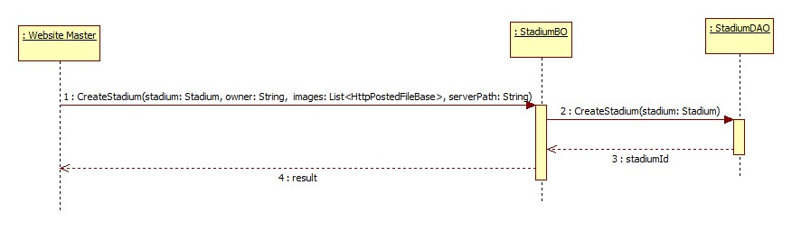

Figure 39: Create Stadium

#### Suggest Stadium

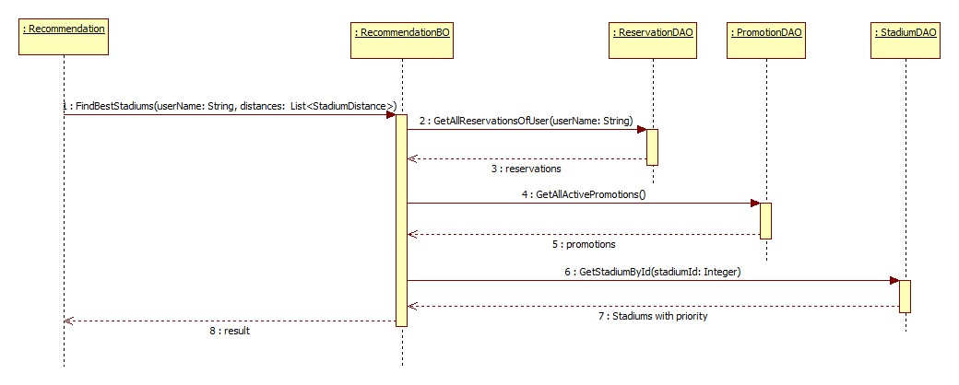

Figure 40: Suggest Stadium

#### Delete Member Rank

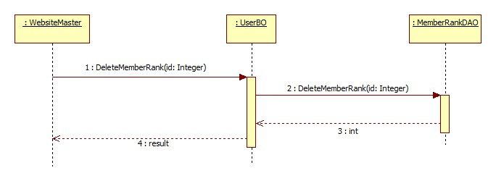

Figure 41: Delete Member Rank

#### Create Price Table

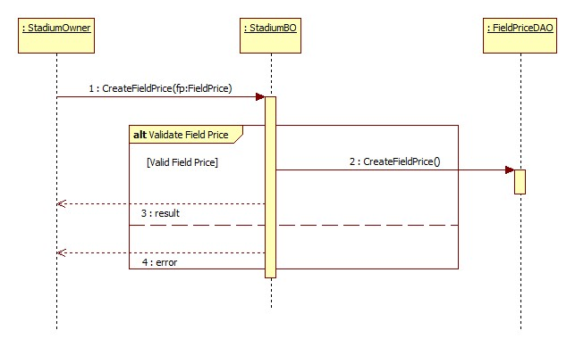

Figure 42: Create Price Table

#### Create Reservation

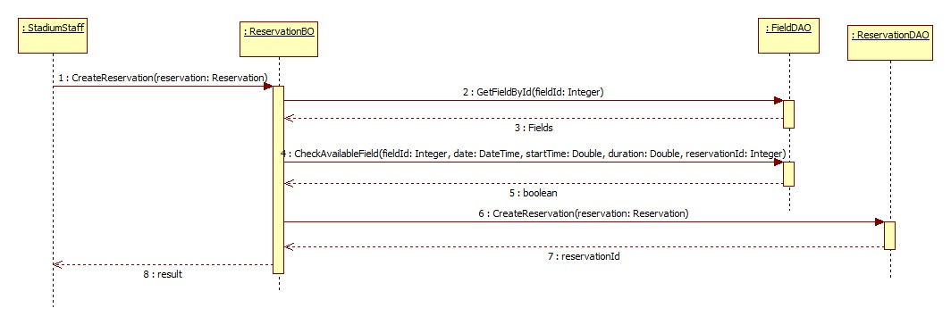

Figure 43: Create Reservation

#### Update Reservation

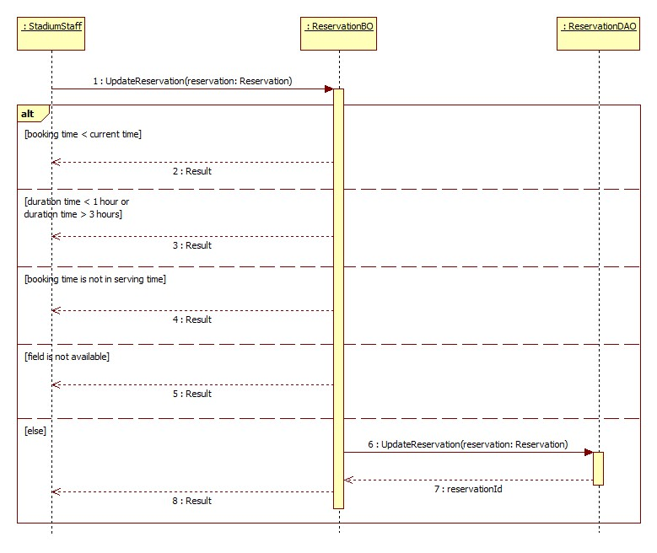

Figure 44: Update Reservation

#### Find Available Stadium

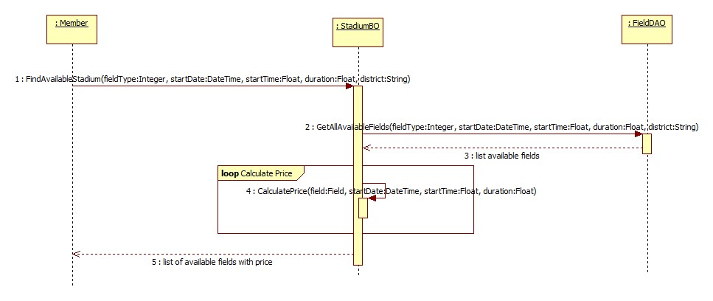

Figure 45: Find Available Stadium

#### Create Promotion

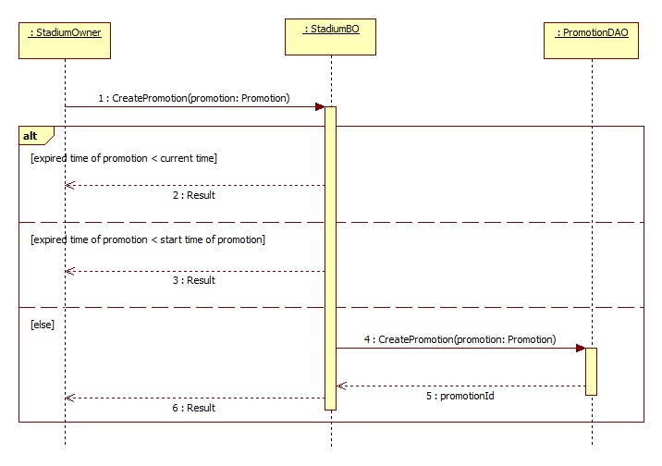

Figure 46: Create Promotion

#### Book Field

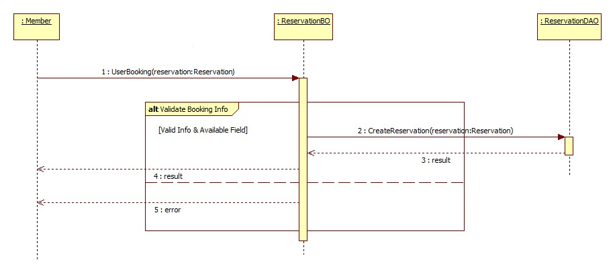

Figure 47: Book Field

#### Cancel Reservation

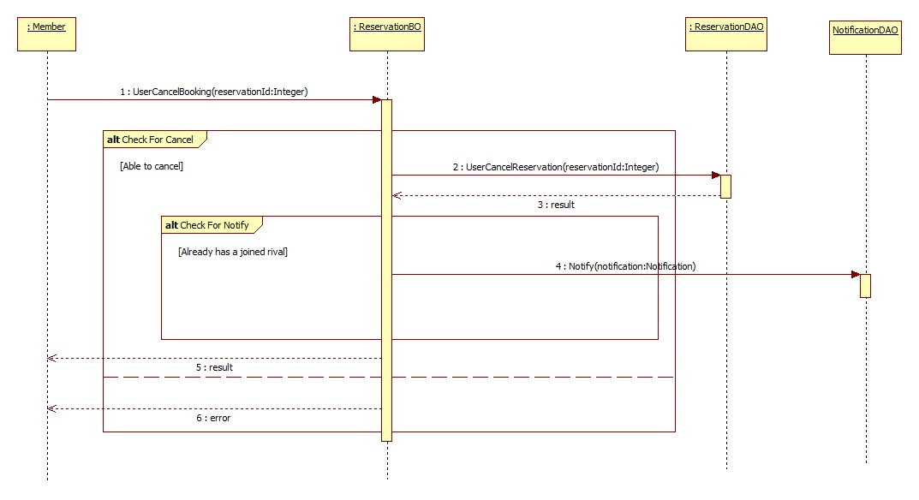

Figure 48: Cancel Reservaion

#### Find Rival

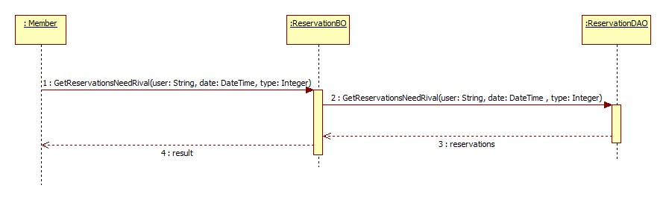

Figure 49: Find Rival

#### Join Match

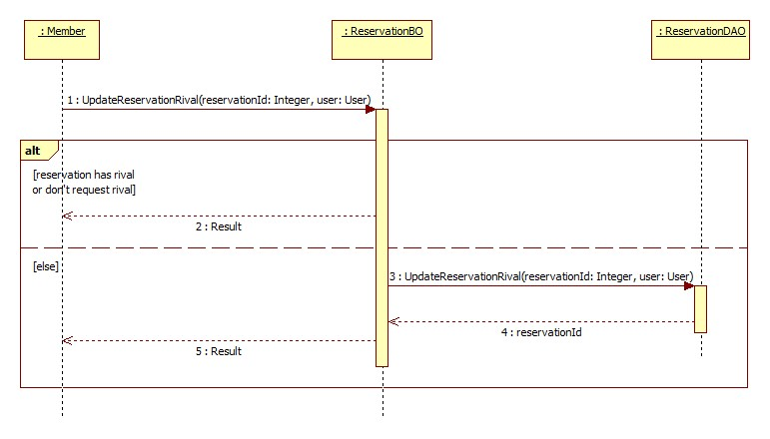

Figure 50: Join Match

#### Reference Sequence Diagrams

The following sequences diagram is referenced to: CD\reports\Report4.docx

* View Booking History
* Rate Stadium
* Review Stadium
* Update Account Profile
* Feedback Website
* Request Join System
* Update Stadium
* Update Configuration
* Suggest Rival
* View Stadiums
* Create Member Rank
* Update Member Rank
* View Member Ranks
* Create Advertising
* Update Advertising
* Delete Advertising
* View Advertisings
* Punish User
* Update User
* View Users
* Update Stadium Profile
* Update Field
* View Fields
* Approve Reservation
* Decline Reservation
* View Reservations
* Update Promotion
* View Promotions
* Find Stadium
* View Stadium Detail

### User Interface Design/ Hardware Interface Design (if any)

Update Later

### Database Design

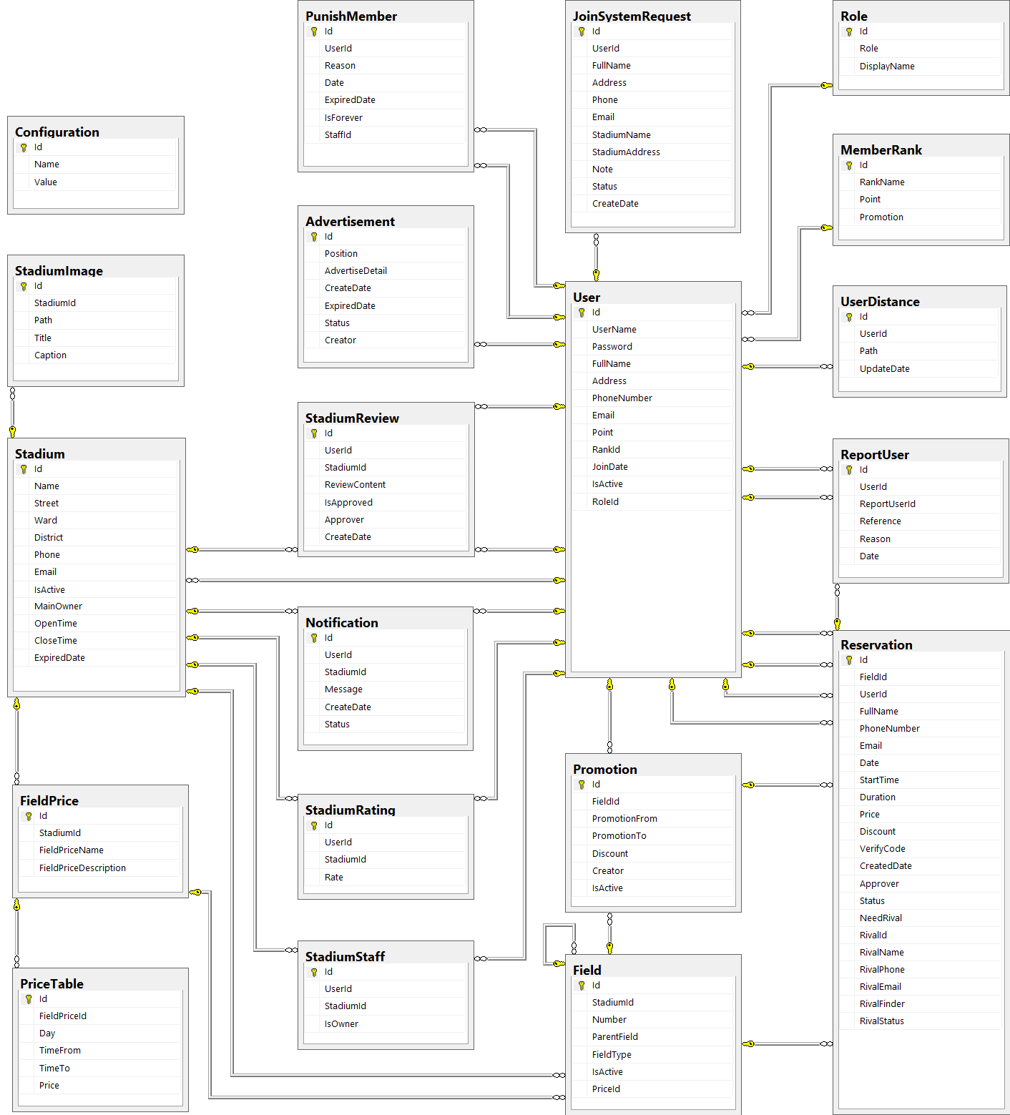

Figure 51: Database Diagram

#### Tables description

|  |  |  |
| --- | --- | --- |
| No. | Table name | Description |
| 1 | Advertisement | Store information about advertising of website |
| 2 | Configuration | Store information about configuration of website |
| 3 | Field | Store information about fields in system |
| 4 | FieldPrice | Store information about price of stadiums in system |
| 5 | JoinSystemRequest | Store information about join system requests in system |
| 6 | MemberRank | Store information about rank of member in system |
| 7 | Notification | Store information about notification of members and stadiums in system |
| 8 | PriceTable | Store informatino about price table of field price in system |
| 9 | Promotion | Store information about promotions of stadiums in system |
| 10 | PunishMember | Store information about punishing members in system |
| 11 | ReportUser | Store information about reporting users in system |
| 12 | Reservation | Store information about reservations of stadiums in system |
| 13 | Role | Store information about roles of user in system |
| 14 | Stadium | Store information about stadiums in system |
| 15 | StadiumImage | Store information about images of stadiums in system |
| 16 | StadiumRating | Store information about rating of stadiums in system |
| 17 | StadiumReview | Store information about reviews of stadiums in system |
| 18 | StadiumStaff | Store information about staffs of stadiums in system |
| 19 | User | Store information about users in system |
| 20 | UserDistance | Store information about the distance of users in system |

#### Advertisement

|  |  |  |  |  |  |  |
| --- | --- | --- | --- | --- | --- | --- |
| Field name | Type | Null | Unique | P/F key | Default | Description |
| Id | int |  |  | PK |  | The index of this advertising |
| Position | nvarchar(10) |  |  |  |  | The position to display of the advertising |
| AdvertiseDetail | ntext |  |  |  |  | The content of this advertising |
| CreateDate | date |  |  |  |  | The date when this advertising is created |
| ExpiredDate | date |  |  |  |  | The date when this advertising is expired |
| Status | nvarchar(50) |  |  |  |  | The status of this advertising |
| Creator | int | true |  | FK |  | The creator who is created this advertising |

#### Configuration

|  |  |  |  |  |  |  |
| --- | --- | --- | --- | --- | --- | --- |
| Field name | Type | Null | Unique | P/F key | Default | Description |
| Id | int |  |  | PK |  | The index of this configuration |
| Name | nvarchar(100) |  |  |  |  | The name of this configuration |
| Value | nvarchar(100) |  |  |  |  | The value of this configuration |

#### Field

|  |  |  |  |  |  |  |
| --- | --- | --- | --- | --- | --- | --- |
| Field name | Type | Null | Unique | P/F key | Default | Description |
| Id | int |  |  | PK |  | The index of this field |
| StadiumId | int |  |  | FK |  | The index of stadium which contain this field |
| Number | nvarchar(5) |  |  |  |  | The number of this field |
| ParentField | int | true |  | FK |  | The index of field which is parent of this field |
| FieldType | int |  |  |  |  | The type of this field |
| IsActive | bit | true |  |  |  | The status of this field |
| PriceId | int |  |  | FK |  | The index of price of this field |

#### FieldPrice

|  |  |  |  |  |  |  |
| --- | --- | --- | --- | --- | --- | --- |
| Field name | Type | Null | Unique | P/F key | Default | Description |
| Id | int |  |  | PK |  | The index of price of field |
| StadiumId | int |  |  | FK |  | The index of stadium |
| FieldPriceName | nvarchar(200) |  |  |  |  | Price name of this field |
| FieldPriceDescription | nvarchar(200) |  |  |  |  | Description of the field price |

#### JoinSystemRequest

|  |  |  |  |  |  |  |
| --- | --- | --- | --- | --- | --- | --- |
| Field name | Type | Null | Unique | P/F key | Default | Description |
| Id | int |  |  | PK |  | The index of this join system request |
| UserId | int |  |  | FK |  | The user who send this join system request |
| FullName | nvarchar(50) |  |  |  |  | The full name of user who send this join system request |
| Address | nvarchar(100) |  |  |  |  | The address of user who send this join system request |
| Phone | nvarchar(20) |  |  |  |  | The phone number of user who send this join system request |
| Email | nvarchar(50) |  |  |  |  | The email of user who send this join system request |
| StadiumName | nvarchar(100) |  |  |  |  | The name of stadium which is user want to join system |
| StadiumAddress | nvarchar(100) |  |  |  |  | The address of stadium which is user want to join system |
| Note | nvarchar(1000) | true |  |  |  | The note of this request |
| Status | nvarchar(50) |  |  |  |  | The status of this request |
| CreateDate | datetime |  |  |  |  | The date when this request is created |

#### MemberRank

|  |  |  |  |  |  |  |
| --- | --- | --- | --- | --- | --- | --- |
| Field name | Type | Null | Unique | P/F key | Default | Description |
| Id | int |  |  | PK |  | The index of this rank |
| RankName | nvarchar(50) |  |  |  |  | The name of this rank |
| Point | int |  |  |  |  | This point is condition to have this user rank |
| Promotion | nvarchar(500) | true |  |  |  | The promotion for user who have this rank |

#### Notification

|  |  |  |  |  |  |  |
| --- | --- | --- | --- | --- | --- | --- |
| Field name | Type | Null | Unique | P/F key | Default | Description |
| Id | int |  |  | PK |  | The index of this notification |
| UserId | int |  |  | FK |  | Index of this user |
| StadiumId | int |  |  | Fk |  | Index of the stadium |
| Message | nvarchar(2000) |  |  |  |  | Content of message |
| CreateDate | datetime |  |  |  |  | Time when notification appear |
| Status | Nvarchar(50) |  |  |  |  | Status of this notification |

#### Pricetable

|  |  |  |  |  |  |  |
| --- | --- | --- | --- | --- | --- | --- |
| Field name | Type | Null | Unique | P/F key | Default | Description |
| Id | int |  |  | PK |  | The index of this price table |
| FieldPriceId | int |  |  | FK |  | The name of this rank |
| Day | int |  |  |  |  | Day of this price table |
| TimeFrom | float |  |  |  |  | Start time of this price table |
| TimeTo | float |  |  |  |  | End time of this price table |
| Price | float |  |  |  |  | Price of each price table |

#### Promotion

|  |  |  |  |  |  |  |
| --- | --- | --- | --- | --- | --- | --- |
| Field name | Type | Null | Unique | P/F key | Default | Description |
| Id | int |  |  | PK |  | The index of this promotion |
| FieldId | int |  |  | FK |  | The index of field which this promotion apply |
| PromotionFrom | date |  |  |  |  | The time when this promotion is started |
| PromotionTo | date |  |  |  |  | The time when this promotion is finished |
| Discount | float |  |  |  |  | The discount per cent of this promotion |
| Creator | int | true |  |  |  | The creator who is created this promotion |
| IsActive | bit | true |  |  |  | The status of this promotion |

#### Punish Member

|  |  |  |  |  |  |  |
| --- | --- | --- | --- | --- | --- | --- |
| Field name | Type | Null | Unique | P/F key | Default | Description |
| Id | int |  |  | PK |  | The index of this punishing |
| UserId | int |  |  | FK |  | The index of user who will be punished |
| Reason | Nvarchar(200) |  |  |  |  | Reason of this punishing |
| Date | datetime |  |  |  |  | Punish time of this punishing |
| ExpiredDate | datetime |  |  |  |  | Unbanned time of this punishing |
| IsForever | bit |  |  |  |  | Check is it forever punish |
| StaffId | int | true |  | FK |  | Index of the staff who is punish this user |

#### Report user

|  |  |  |  |  |  |  |
| --- | --- | --- | --- | --- | --- | --- |
| Field name | Type | Null | Unique | P/F key | Default | Description |
| Id | int |  |  | PK |  | The index of this promotion |
| UserId | int |  |  | FK |  | The index of the user who is reported |
| ReportUserId | int |  |  |  |  | The index of the user who reports |
| Reason | nvarchar(50) |  |  |  |  | Reason of the report |
| Reference | int |  |  | FK |  | Reference of this report |
| Date | date |  |  |  |  | Create date of this report |

#### Reservation

|  |  |  |  |  |  |  |
| --- | --- | --- | --- | --- | --- | --- |
| Field name | Type | Null | Unique | P/F key | Default | Description |
| Id | int |  |  | PK |  | The index of this reservation |
| FieldId | int |  |  | FK |  | The index of field is booked |
| UserId | int | true |  | FK |  | The index of user who book the field |
| FullName | nvarchar(50) |  |  |  |  | The full name of user who book the field |
| PhoneNumber | nvarchar(20) |  |  |  |  | The phone number of user who book the field |
| Email | nvarchar(50) | true |  |  |  | The email of user who book the field |
| Date | date |  |  |  |  | The date that is booked the field |
| StartTime | float |  |  |  |  | The start time when user need the field |
| Duration | float |  |  |  |  | The duration time that user need the field |
| Price | float |  |  |  |  | The price of field |
| Discount | float | true |  |  |  | The discount per cent of the promotion is applied to this reservation |
| VerifyCode | nvarchar(50) |  |  |  |  | The code which use for verifying this reservation |
| CreatedDate | datetime |  |  |  |  | The date when this reservation is created |
| Approver | int | true |  | FK |  | The index of stadium staff who approve this reservation |
| Status | nvarchar(20) |  |  |  |  | The status about approving of this reservation |
| NeedRival | bit |  |  |  |  | The status about having rival of this reservation |
| RivalId | int | true |  | FK |  | The index of rival who join this request rival of this reservation |
| RivalName | nvarchar(50) | true |  |  |  | The name of rival who join this request rival of this reservation |
| RivalPhone | nvarchar(20) | true |  |  |  | The phone number of rival who join this request rival of this reservation |
| RivalEmail | nvarchar(50) | true |  |  |  | The email of rival who join this request rival of this reservation |
| RivalFinder | int | true |  |  |  | The index of user who find rival for this request rival of this reservation |
| RivalStatus | nvarchar(20) | true |  |  |  | The status about approving of this rival |

#### Role

|  |  |  |  |  |  |  |  |  |  |  |  |  |
| --- | --- | --- | --- | --- | --- | --- | --- | --- | --- | --- | --- | --- |
| Field name | Type | | Null | | Unique | | P/F key | | Default | | Description | |
| Id | | int | |  | |  | | PK, FK | |  | | The index of this role |
| Role | | nvarchar(50) | |  | |  | |  | |  | | The name of this role |
| DisplayName | | nvarchar(50) | | true | |  | |  | |  | | The display name of this role |

#### Stadium

|  |  |  |  |  |  |  |
| --- | --- | --- | --- | --- | --- | --- |
| Field name | Type | Null | Unique | P/F key | Default | Description |
| Id | int |  |  | PK |  | The index of this stadium |
| Name | nvarchar(100) |  |  |  |  | The name of this stadium |
| Street | nvarchar(50) |  |  |  |  | The street address of this stadium |
| Ward | nvarchar(50) |  |  |  |  | The ward address of this stadium |
| District | nvarchar(50) |  |  |  |  | The district address of this stadium |
| Description | nvarchar(500) |  |  |  |  | The description about this stadium |
| Phone | nvarchar(20) |  |  |  |  | The phone number to contact with this stadium staff |
| Email | nvarchar(50) |  |  |  |  | The email to contact with this stadium staff |
| IsActive | bit | true |  |  |  | The status of this stadium |
| MainOwner | int |  |  | FK |  | The owner of this stadium |
| OpenTime | float |  |  |  |  | Opened time of this stadium |
| CloseTime | float |  |  |  |  | Closed time of this stadium |
| ExpiredDate | date |  |  |  |  | Limited date of this stadium |

#### StadiumImage

|  |  |  |  |  |  |  |
| --- | --- | --- | --- | --- | --- | --- |
| Field name | Type | Null | Unique | P/F key | Default | Description |
| Id | int |  |  | PK |  | The index of this image |
| StadiumId | int |  |  | FK |  | The index of stadium which the image about |
| Path | nvarchar(100) |  |  |  |  | The path of this image store in server |
| Title | nvarchar(100) | true |  |  |  | The title of this image |
| Caption | nvarchar(200) | true |  |  |  | The caption of this image |

#### StadiumRating

|  |  |  |  |  |  |  |
| --- | --- | --- | --- | --- | --- | --- |
| Field name | Type | Null | Unique | P/F key | Default | Description |
| Id | int |  |  | PK |  | The index of this rating |
| UserId | int |  |  | FK |  | The index of user who rate the stadium |
| StadiumId | int |  |  | FK |  | The index of stadium which is rated |
| Rate | float |  |  |  |  | The point of this rating |

#### StadiumReview

|  |  |  |  |  |  |  |  |  |  |  |  |  |
| --- | --- | --- | --- | --- | --- | --- | --- | --- | --- | --- | --- | --- |
| Field name | Type | | | Null | | Unique | | P/F key | | Default | | Description |
| Id | | int |  | |  | | PK | |  | | The index of this review | |
| UserId | | int |  | |  | | FK | |  | | The index of user who review the stadium | |
| StadiumId | | int |  | |  | | FK | |  | | The index of stadium which is reviewed | |
| ReviewContent | | nvarchar(500) |  | |  | |  | |  | | The content of this review | |
| IsApproved | | bit |  | |  | |  | |  | | The status about approving of this review | |
| Approver | | int | true | |  | | FK | |  | | The index of stadium staff who approve this review | |
| CreateDate | | datetime |  | |  | |  | |  | | The date when this review is created | |

#### StadiumStaff

|  |  |  |  |  |  |  |  |  |  |  |  |  |
| --- | --- | --- | --- | --- | --- | --- | --- | --- | --- | --- | --- | --- |
| Field name | Type | | Null | | Unique | | P/F key | | Default | | Description | |
| Id | | int | |  | |  | | PK | |  | | The index of this stadium staff |
| UserId | | int | |  | |  | | FK | |  | | The index of user who is staff of stadium |
| StadiumId | | int | |  | |  | | FK | |  | | The index of stadium |
| IsOwner | | bit | |  | |  | |  | |  | | The role of this staff |

#### User

|  |  |  |  |  |  |  |
| --- | --- | --- | --- | --- | --- | --- |
| Field name | Type | Null | Unique | P/F key | Default | Description |
| Id | int |  |  | PK |  | The index of this user |
| UserName | nvarchar(50) |  |  |  |  | The user name of this user |
| Password | nvarchar(50) |  |  |  |  | The password of this user |
| FullName | nvarchar(50) | true |  |  |  | The full name of this user |
| Address | nvarchar(100) | true |  |  |  | The address of this user |
| PhoneNumber | nvarchar(20) | true |  |  |  | The phone number of this user |
| Email | nvarchar(50) |  |  |  |  | The email of this user |
| Point | int |  |  |  |  | The point of this user |
| RankId | int |  |  | FK |  | The index of rank of this user |
| JoinDate | date |  |  |  |  | The date when user register at website |
| IsActive | bit |  |  |  |  | The status of this user |
| RoleId | int |  |  |  |  | The index of role of this user |

#### UserDistance

|  |  |  |  |  |  |  |  |  |  |  |  |  |
| --- | --- | --- | --- | --- | --- | --- | --- | --- | --- | --- | --- | --- |
| Field name | Type | | Null | | Unique | | P/F key | | Default | | Description | |
| Id | | int | |  | |  | | PK | |  | | The index of the user stadium |
| UserId | | int | |  | |  | | FK | |  | | The index of the user |
| Path | | nvarchar(50) | |  | |  | |  | |  | | The path of this user distance |
| IsOwner | | bit | |  | |  | |  | |  | | The role of this staff |

### Business Intelligence Agent: Suggestion Method

#### Overview:

This automatic function helps system to suggest stadium or rival when users login. It makes the website becomes more friendly and convenience for user. We apply Google API to calculate the distance from user’s address to stadium’s address, storage the reservation history of user to understand their habits, and get the promoted information of stadium to give user best advices.

Therefore we use three norms to recommend the stadium for user:

* Most booked stadium
* The nearest stadium
* Stadium which is discounted

#### Implement:

* User logins system
* System gets the reservation history of this user, all the available promoted stadiums and the distance from user to each stadium.
* Each recommended stadium is calculated by three norms: the stadium which is most booked, the stadium which is nearest to user’s address and the most discount stadium.
* System calculates the priority of each norms and combines it into final priority to decide the order of stadium which is displayed on Homepage.
* Homepage has 4 categories of stadium: The best stadium (balance rate of priority), most booked stadium(highest priority rate for the most booked stadium), most nearest stadium (highest priority rate for the nearest stadium), and most discount stadium (highest priority rate for the most discounted stadium).
* The best stadium, most booked stadium, most nearest stadium, and most discount stadium have the same method to be suggested but they have the difference value of priority rate.
* For example, Most Booked Stadium is suggested by: the highest priority rate for most booked stadium (60 percent), the lower priority rate for near stadium (20 percent) and discounted stadium (20 percent).
* In addition, the value of priority rate is able to be changed. It depend on taste of customer. If they interest more about near stadium, website master can raise the rate of nearest stadium priority, and decrease the others dow.

Beside that we apply the same way to suggest rival for player who wants to find competitors or have not enough players for a match.

Suggest Stadium

The Best Stadium

The Nearest Stadium

The Most

Booked Stadium

The Most

Discounted Stadium

Nearest priority

Most booked

priority

Most discounted

priority

Nearest priority

Most booked

priority

Most discounted

priority

Nearest priority

Most booked

priority

Most discounted

priority

Nearest priority

Most booked

priority

Most discounted

priority

Figure 52: Stadium Suggestion

#### Algorithm

**Most Booked Stadium Point (MBSP):**

* Get all reservation, we assume number of stadiums were booked
* Reduced Point = 10 / number of stadiums were booked
* Stadium with max reservation: set 10 mark
* Next Stadium mark =

10 – [(Max reservation number – Next reservation number) x Reduced Point]

* Calculate to the end of booked stadiums list
* We have mark of each booked stadium

**Most Discounted Stadium Point(MDSP):**

* Get all available promoted stadium, assume number of stadium are being discounted
* Reduced Point = 10 / number of stadium are being discounted.
* Stadium with the highest discount: set 10 mark
* Next Stadium mark =

10 – [(highest discount amount – next discount amount) x Reduced Point]

* Calculate to the end of the discounted stadiums list.
* We have mark of each promoted satdium

**Nearest Priority Stadium Point(NPSP):**

* Distance from user’s address to stadium < 2km: set 10 mark
* Distance from user’s address to stadium < 4km: set 9 mark
* Distance from user’s address to stadium < 8km: set 8 mark
* ….
* Distance from user’s address to stadium out of 20 km: 0 mark

We have mark of each stadium near user’s address

**Summarise:**

* Most booked priority: **MostBooked**
* Most discount priority: **MostPromoted**
* Distance priority: **Nearest**

Final priority of each stadium =

(**MostBooked** x **MBSP) + (MostPromoted** x **MDSP)** + (**Nearest** x **NPSP)**

Note: Value of MostBooked, MostPromoted and Nearest is store in Tbl.Configuration. It’s able to change.

Result: The stadium with the highest priority is display firstly in each category on Home page.

## System Implementation & Test (SIT)

### Introduction

#### System Overview

This document describes the approach and methodologies used by the testing group to plan, organize and manage the testing of this system. It describes implementation details of test cases or technical details of how the product features should work.

The system will be tested is also the system our team are currently developing. This system developed based on MVC4 framework.

#### Test Approach

* Test goals: the testing aims to identify the remaining bugs in the system before releasing and confirm the consistency in design and implementation.
* Test type: black box testing.
* Test level: system and integration test.

### Test Plan

The purpose of this section is to verify and ensure that BUSG meets its design specification and other requirements from user. The following part will describe which features will be tested and which will not.

#### Functions

##### Role ‘Website Master’

Test all functions of role ‘Website Master’ including:

* Stadium Management
* User Management
* Advertise Management
* Request Join System Management

##### Role ‘Stadium Owner’

* Field Management
* Stadium Management
* Promotion Management
* Reservation Management

##### Role ‘Member’

* Account Management
* Feedback Management
* Find
* Booking Field Management

#### Features not to be tested

##### Performance test

There was not enough time so we cannot optimize source code and improve performance. We can only ensure the system work well but not at its best performance.

##### Testing Tools and Environment

* Windows 7 operating system
* Google Chrome 19 or higher
* Microsoft Visual Studio 2012
* Microsoft SQL Server 2008 R2

### Test Cases

#### Role ‘Website Master’

##### Stadium Managements

|  |  |  |  |  |  |
| --- | --- | --- | --- | --- | --- |
| **Test case No** | **Test case** | **Input** | **Expected Result** | **Status** | **Note** |
| **View Stadium Management** | | | | | |
| TC_1 | Test View Stadium List | 1. Login the system as WebsiteMaster. 2. Click “Quản trị website” link 3. Click “Sân bóng” link | “Quản lý sân bóng” page is displayed with the following informations:  - Image of Stadium - Tên sân bóng - Địa chỉ - Số điện thoại - Đánh giá  - “Thêm sân mới” button | Tested |  |
| **Create Stadium** | | | | | |
| TC_2 | Test View Create Stadium Form | 1. Login the system as WebsiteMaster. 2. Click “Quản trị website” link 3. Click “Sân bóng” link  4. Click “Thêm sân mới” button | “Thêm sân bóng” page is displayed with the following field:  - Tên sân bóng - Chủ sân  - Ngày hết hạn - Số điện thoại  - Email - Đường, phường , quận  - Hình ảnh sân  - Giờ hoạt động  - Thêm hình ảnh sân  - Trạng thái hoạt động  - “Lưu” button & “Hủy bỏ” button | Tested |  |
| TC_3 | Test Create Stadium Successfully | 1. Insert stadium's information 2. Click “Lưu” button | Display success message Redirect to “Quản lý sân bóng” page | Tested |  |
| TC_4 | Test Create Stadium With Blank Field | 1. Insert stadium's information 2. Leave empty some fields 3. Click “ Lưu” button | Error message will be displayed: “Xin hãy điền đầy đủ những thông tin bắt buộc” | Tested |  |
| TC_5 | Test Cancel Create Stadium | 1. Insert stadium's information 2. Click “Hủy bỏ” button | Confirm discard all recent activity is displayed Redirect to “Quản lý sân bóng” page | Tested |  |
| **Edit Stadium** | | | | | |
| TC_6 | Test View Edit Stadium Form | 1. Login the system as WebsiteMaster. 2. Click “Quản trị website” link 3. Click “Sân bóng” link  4. Click “Chỉnh sửa” button | “Chỉnh sửa thông tin sân bóng” page is displayed with the following field: - Tên sân bóng - Chủ sân  - Ngày hết hạn - Số điện thoại  - Email - Đường, phường , quận  - Hình ảnh sân  - Giờ hoạt động  - Thêm hình ảnh sân  - Trạng thái hoạt động  - “Lưu” button & “Hủy bỏ” button | Tested |  |
| TC_7 | Test Edit Stadium Successfully | 1. Insert stadium's information 2. Click “Lưu” button | Display success message Redirect to “Quản lý sân bóng” page | Tested |  |
| TC_8 | Test Edit Stadium With Blank Field | 1. Insert stadium's information  2. Leave empty some fields  3. Click “Lưu” button | Error message will be displayed: “Xin hãy điền đầy đủ những thông tin bắt buộc”. | Tested |  |
| TC_9 | Test Cancel Edit Stadium | 1. Insert stadium's information  2. Click “Hủy bỏ” button | Confirm discard all recent activity is displayed Redirect to “Quản lý sân bóng” page | Tested |  |
| **Update Stadium Status** | | | | | |
| TC_10 | Test Active Stadium | 1. Login the system as WebsiteMaster. 2. Click “Quản trị website” link 3. Click “Sân bóng” link  4. Click “Chỉnh sửa” button  5. Choose “Đang hoạt động” in “Trạng thái hoạt động” drop down list of the stadium which will be active  6. Click “Lưu” button | New message will be displayed: “Cập nhật thành công”  The Stadium status changes from deactive to active | Tested |  |
| TC_11 | Test Deactive Stadium | 1. Login the system as WebsiteMaster. 2. Click “Quản trị website” link 3. Click “Sân bóng” link  4. Click “Chỉnh sửa” button  5. Choose “Không hoạt động” in “Trạng thái hoạt động” drop down list of the stadium which will be active  6. Click “Lưu” button | New message will be displayed : “Cập nhật thành công”  The Stadium status changes from deactive to active | Tested |  |

##### User Managements

|  |  |  |  |  |  |
| --- | --- | --- | --- | --- | --- |
| **Test case No** | **Test case** | **Input** | **Expected Result** | **Status** | **Note** |
| **View User Management** | | | | | |
| TC_12 | Test View User List | 1. Login the system as WebsiteMaster. 2. Click “Quản trị website” link 3. Click “Thành viên” link | “ Quản lý thành viên “ page is displayed with the following informations: - Thành viên - Tên đầy đủ - Địa chỉ  - Email  - Quyền hạn  - “Tìm kiếm” textbox  - “Tìm kiếm” button & “Xem tất cả” button | Tested |  |
| **Update User's Profiles** | | | | | |
| TC_13 | Test View Update User's Profiles Form | 1. Login the system as WebsiteMaster. 2. Click “Quản trị website” link 3. Click “Thành Viên” link  4. Click user which will be edited | “Chỉnh sửa thông tin thành viên” page is displayed with the following informations: - Tên đăng nhập - Tên thành viên  - Địa chỉ  - Số điện thoại - “Email” textbox  - “Mật khẩu” textbox & “ Xác nhận mật khẩu “ textbox  - Point  - “Quyền hạn” drop down list  - “Lưu” button & “Hủy bỏ” button | Tested |  |
| TC_14 | Test Update User's Profiles Successfully | 1. Insert new User's information 2. Click “Lưu” button | Redirect to “Quản lý thành viên” page | Tested |  |
| TC_15 | Test Update User's Profiles With Blank Field | 1. Insert new User's information  2. Leave empty some fields 3. Click “Lưu” button | Error message will be displayed: “Xin hãy điền đầy đủ những thông tin bắt buộc” | Tested |  |
| TC_16 | Test Cancel Update User's Profiles | 1. Insert new User's information 2. Click “Hủy bỏ” button | Confirm discard all recent activity is displayed Redirect to “Quản lý thành viên” page | Tested |  |

#### Role ‘Stadium Owner’

##### Field Managements

|  |  |  |  |  |  |
| --- | --- | --- | --- | --- | --- |
| **Test case No** | **Test case** | **Input** | **Expected Result** | **Status** | **Note** |
| **View List Fields** | | | | | |
| TC_17 | Test viewing “Quản lý sân con” list | 1. Login the system as StadiumOwner  2. Click “Quản lý sân bóng” link  3. Click “Sân bóng” link  4. Click “Sân con” link | “Quản lý sân con” page is displayed as list with the following informations:  - “Tên sân” - “Kiểu sân”  - “Tên sân cha”  - “Trạng thái”  - “Chỉnh sửa” link & “Thêm sân con” link & “Bảng giá” link | Tested |  |
| **Create Field** | | | | | |
| TC_18 | Test creating a field with blank fields | 1. Login the system as StadiumOwner  2. Click “Quản lý sân bóng” link  3. Click “Sân bóng “ link  4. Click “Sân con” link  5. Click “Thêm sân con” button  6. Leave empty some fields  7. Click “Lưu” button | Error message will be displayed:  - “Bạn cần sử dụng mẫu nhập bên dưới để thêm đầy đủ thông tin vào sân bóng”. | Tested |  |
| TC_19 | Test creating a field but don’t have price list | 1. Login the system as StadiumOwner  2. Click “Quản lý sân bóng” link  3. Click “Sân bóng “ link  4. Click “Sân con” button  5. Click “Thêm sân con” button  6. Click “đây” link | Error message will be displayed:  - “Bạn cần them bảng giá vào hệ thống trước khi thêm sân con vào hệ thống. Click vào đây “link” để đến trang thêm bảng giá”.  - Redirect to “Thêm bảng giá” page | Tested |  |
| TC_20 | Test creating a field | 1. Login the system as StadiumOwner  2. Click “Quản lý sân bóng” link  3. Click “Sân bóng” link  4. Click “Sân con” link  5. Click “Thêm sân con” button  6. Input require information  7. Click “Lưu” button | Create successfully  Redirect to “Quản lý sân con” page with new “Sân con” is created | Tested |  |
| TC_21 | Test cancel creating action | 1. Login the system as StadiumOwner  2. Click “Quản lý sân bóng” link  3. Click “ Sân bóng” link  4. Click “ Sân con” link  5. Click “Thêm sân con” button  6. Click “Huỷ bỏ” button | Confirm discard all recent activity is displayed Redirect to “Quản lý sân con” page | Tested |  |
| **Update Field** | | | | | |
| TC_22 | Test updating a field with blank fields | 1. Login the system as StadiumOwner  2. Click “Quản lý sân bóng” link  3. Click “Sân bóng” link  4. Click “Sân con” link  5. Click “Chỉnh sửa” button  6. Leave empty some fields  7. Click “Lưu” button | Error message will be displayed:  - “Bạn cần sử dụng mẫu nhập bên dưới để thêm đầy đủ thông tin vào sân bóng”. | Tested |  |
| TC_23 | Test updating a field | 1. Login the system as StadiumOwner  2. Click “Quản lý sân bóng” link  3. Click “Sân bóng” link  4. Click “Sân con” link  5. Click “Chỉnh sửa” button  6. Insert field's information  7. Click “Lưu” button | Update Successfully Redirect to “Quản lý sân con” page | Tested |  |
| TC_24 | Test cancel updating action | 1. Login the system as StadiumOwner  2. Click “Quản lý sân bóng” link  3. Click “Sân bóng” link  4. Click “Sân con” link  5. Click “Chỉnh sửa” button  6. Click “Huỷ” button | Confirm discard all recent activity is displayed Redirect to “Quản lý sân con” page | Tested |  |
| TC_25 | Test active a field | 1. Login the system as StadiumOwner  2. Click “Quản lý sân bóng” link  3. Click “Sân bóng” link  4. Click “Sân con” link  5. Click “Chỉnh sửa” button  6. Choose “Đang hoạt động” in “Trạng thái hoạt động” drop down list of the advertising which will be active  7. Click “Lưu” on button | New message will be displayed: “Cập nhật thành công”  The Field status changes from deactive to active | Tested |  |
| TC_26 | Test deactive a field | 1. Login the system as StadiumOwner  2. Click “Quản lý sân bóng” link  3. Click “Sân bóng” link  4. Click “Sân con” link  5. Click “Chỉnh sửa” button  6. Choose “Không hoạt động “ in “Trạng thái hoạt động” drop down list of the advertising which will be deactive  7. Click “Lưu” button | New message will be displayed: “Cập nhật thành công “  The Fields atus changes from active to deactive | Tested |  |

##### Promotion Managements

|  |  |  |  |  |  |
| --- | --- | --- | --- | --- | --- |
| **Test case No** | **Test case** | **Input** | **Expected Result** | **Status** | **Note** |
| **View List Promotions** | | | | | |
| TC_27 | Test viewing Promotion Management pagepage | 1. Login the system as StadiumOwner  2. Click “Quản lý sân bóng” link  3. Click “Khuyến mãi” link  4. Click stadium you want to view promotion | “Quản lý khuyến mãi” page is displayed as list with the following informations:  - Số sân  - Thời gian khuyến mãi  - Giảm giá  - Trạng thái hoạt động  - “Thêm khuyến mãi” button & “Chỉnh sửa” link | Tested |  |
| **Create Promotion** | | | | | |
| TC_28 | Test creating a promotion with blank fields | 1. Login the system as StadiumOwner  2. Click “Quản lý sân bóng” link  3. Click “Khuyến mãi” link  4. Click stadium you want to view promotion  5. Click “Thêm khuyến mãi” button  6. Leave empty some fields  7. Click “Lưu” button | Error message will be displayed:  - “Xin vui lòng chọn thời gian khuyến mãi  - “ Xin nhập và số ưu đãi giảm giá”. | Tested |  |
| TC_29 | Test creating a promotion with “Thời gian kết thúc” is over | 1. Login the system as StadiumOwner  2. Click “Quản lý sân bóng” link  3. Click “Khuyến mãi” link  4. Click stadium you want to view promotion  5. Click”Thêm khuyến mãi” button  6. Input require information  - Select “1” in “Số sân” field  - Select “05/03/2014” in “Thời gian bắt đầu”  - Select “06/03/2014” in “Thời gian kết thúc” field  - Input “10” into “Giảm giá (%)” field  7. Click “Lưu” button | Error message will be displayed:  - “Thời gian khuyến mãi đã kết thúc, xin vui lòng chọn thời gian kết thúc khác”. | Tested |  |
| TC_30 | Test creating a promotion with “Thời gian kết thúc” before “Thời gian bắt đầu” | 1. Login the system as StadiumOwner  2. Click “Quản lý sân bóng” link  3. Click “Khuyến mãi” link  4. Click stadium you want to view promotion  5. Click “Thêm khuyến mãi” button  6. Input require information  - Select “1” in “Số sân” field  - Select “25/03/2014” in “Thời gian bắt đầu” field  - Select “20/03/2014” in “Thời gian kết thúc” field  - Input “10” into “Giảm giá (%)” field  7. Click”Lưu” button | Error message will be displayed:  - “Thời gian khuyến mãi không đúng, vui lòng chọn thời gian khác”. | Tested |  |
| TC_31 | Test creating a promotion with “Giảm giá (%)” is not a number | 1. Login the system as StadiumOwner  2. Click “Quản lý sân bóng” link  3. Click “ Khuyến mãi” link  4. Click stadium you want to view promotion  5. Click “Thêm khuyến mãi” button  6. Input require information  - Select “1” in “Số sân” field  - Select “11/11/2014” in “Thời gian bắt đầu” field  - Select “12/12/2014” in “Thời gian kết thúc” field  - Input “12a” into “Giảm giá (%)” field  7.Click”Lưu” button | Error message will be displayed:  - “Giá trị giảm giá không chính xác, vui lòng nhập lại”. | Tested |  |
| TC_32 | Test creating a promotion with “Giảm giá (%)” is not in a space | 1. Login the system as StadiumOwner  2. Go to “Quản lý sân bóng” page  3. Click “Khuyến mãi” link  4. Click stadium you want to view promotion  5. Click “Thêm khuyến mãi” button  6. Input require information  - Select “1” in “Số sân” field  - Select “11/11/2014” in “Thời gian bắt đầu” field  - Select “12/12/2014” in “Thời gian kết thúc” field  - Input “500” into “Giảm giá (%)” field  7.Click “Lưu” button | Error message will be displayed:  - “Yêu cầu giảm giá nằm trong khoảng 0 đến 100”. | Tested |  |
| TC_33 | Test creating a promotion | 1. Login the system as StadiumOwner  2. Click “Quản lý sân bóng” link  3. Click “Khuyến mãi” link  4. Click stadium you want to view promotion  5. Click “Thêm khuyến mãi” button  6. Input require information  - Select “1” in “Số sân” field  - Select “11/11/2014” in “Thời gian bắt đầu” field  - Select “12/12/2014” in “Thời gian kết thúc” field  - Input “10” into “Giảm giá (%)” field  7. Click “Lưu” button | Create successfully  Redirect to “Quản lý khuyến mãi” page with new “Khuyến mãi” is created | Tested |  |
| TC_34 | Test cancel creating action | 1. Login the system as StadiumOwner  2. Click “Quản lý sân bóng” link  3. Click “Khuyến mãi” link  4. Click stadium you want to view promotion  5. Click “Thêm khuyến mãi” button  6. Click “Huỷ bỏ” button | Confirm discard all recent activity is displayed Redirect to “Quản lý khuyến mãi” page | Tested |  |
| **Update Promotion** | | | | | |
| TC_35 | Test updating a promotion with blank fields | 1. Login the system as StadiumOwner  2. Click “Quản lý sân bóng” link  3. Click “Khuyến mãi” link  4. Click stadium you want to view promotion  5. Click “Chỉnh sửa” link on a row  6. Leave empty some fields  7. Click “Lưu” button | Error message will be displayed:  - “Xin vui lòng chọn thời gian khuyến mãi  - “ Xin nhập và số ưu đãi giảm giá”. | Tested |  |
| TC_36 | Test updating a promotion with “Thời gian kết thúc” is over | 1. Login the system as StadiumOwner  2. Click “Quản lý sân bóng” link  3. Click “Khuyến mãi” link  4. Click stadium you want to view promotion  5. Click “Chỉnh sửa” button  6. Input require information  - Select “1” in “Số sân” field  - Input “05/03/2014” into “Thời gian bắt đầu”  - Input “06/03/2014” into “Thời gian kết thúc” field  - Input “10” into “Giảm giá (%)” field  7. Click “Lưu” button | Error message will be displayed:  - “Thời gian khuyến mãi đã kết thúc, xin vui lòng chọn thời gian kết thúc khác”. | Tested |  |
| TC_37 | Test updating a promotion with “Thời gian kết thúc” before “Thời gian bắt đầu” | 1. Login the system as StadiumOwner  2. Click “Quản lý sân bóng” link  3. Click “Khuyến mãi” link  4. Click stadium you want to view promotion  5. Click “Chỉnh sửa” button  6. Input require information  - Select “1” in “Số sân” field  - Input “25/03/2014” into “Thời gian bắt đầu” field  - Input “20/03/2014” into “Thời gian kết thúc” field  - Input “10” into “Giảm giá (%)” field  7. Click”Lưu” button | Error message will be displayed:  - “Thời gian khuyến mãi không đúng, vui lòng chọn thời gian khác”. | Tested |  |
| TC_38 | Test updating a promotion with “Giảm giá (%)” is not a number | 1. Login the system as StadiumOwner  2. Click “Quản lý sân bóng” link  3. Click “Khuyến mãi” link  4. Click stadium you want to view promotion  5. Click “Chỉnh sửa” button  6. Input require information  - Input “12a” into “Giảm giá (%)” field  7.Click”Lưu” button | Error message will be displayed:  - “Giá trị giảm giá không chính xác, vui lòng nhập lại”. | Tested |  |
| TC_39 | Test creating a promotion with “Giảm giá (%)” is not in a space | 1. Login the system as StadiumOwner  2. Click “Quản lý sân bóng” link  3. Click “Khuyến mãi” link  4. Click stadium you want to view promotion  5. Click “Chỉnh sửa “ button  6. Input require information  - Input “500” into “Giảm giá (%)” field  7.Click “Lưu” button | Error message will be displayed:  - “Yêu cầu giảm giá nằm trong khoảng 0 đến 100”. | Tested |  |
| TC_40 | Test updating a promotion | 1. Login the system as StadiumOwner  2. Click “Quản lý sân bóng” link  3. Click “Khuyến mãi” link  4. Click stadium you want to view promotion  5. Click “Chỉnh sửa” button  6. Input require information  - Change value to “2” in “Số sân” field  - Change value to “11/11/2014” in “Thời gian bắt đầu” field  - Change value to “12/12/2014” in “Thời gian kết thúc” field  - Change value to “20” in “Giảm giá (%)” field  7. Click “Lưu” button | Update successfully  Redirect to “Quản lý khuyến mãi” page with new “Khuyến mãi” information is updated | Untested |  |
| TC_41 | Test cancel updating action | 1. Login the system as StadiumOwner  2. Click “Quản lý sân bóng” link  3. Click “Khuyến mãi” link  4. Click stadium you want to view promotion  5. Click “Chỉnh sửa” button  6. Click “Hủy bỏ” button | Confirm discard all recent activity is displayed Redirect to “Quản lý khuyến mãi” page | Tested |  |
| TC_42 | Test activating a promotion | 1. Login the system as StadiumOwner  2. Click “Quản lý sân bóng” link  3. Click “Khuyến mãi” link  4. Click promotion you want to view promotion  5. Click “Chỉnh sửa” button  6. Choose “ Đang hoạt động “ in “Trạng thái hoạt động” drop down list of the promotion which will be active  7. Click”Lưu” button | Update successfully  Redirect to “Quản lý khuyến mãi” page with “Khuyến mãi” is activated | Tested |  |
| TC_43 | Test deactivating a promotion | 1. Login the system as StadiumOwner  2. Click “Quản lý sân bóng” link  3. Click “Khuyến mãi” link  4. Click stadium you want to view promotion  5. Click “Chỉnh sửa” button  6. Choose “Đang hoạt động” in “Trạng thái hoạt động” drop down list of the promotion which will be deactive  7. Click “Lưu” button | Update successfully  Redirect to “Quản lý khuyến mãi” page with “Khuyến mãi” is deactivated | Tested |  |

##### Price Table Management

|  |  |  |  |  |  |
| --- | --- | --- | --- | --- | --- |
| **Test case No** | **Test case** | **Input** | **Expected Result** | **Status** | **Note** |
| **View Price List** | | | | | |
| TC_44 | Test view Price List Management page | 1. Login the system as StadiumOwner  2. Click “Quản lý sân bóng” link  3. Click “Sân bóng” link  4. Click “Bảng giá” link of the stadium which you want to view price list | “Quản lý bảng giá “ page is displayed as list with the following informations:  - “Tên bảng giá” - “Mô tả”  - “Chi tiết“ link & “Xóa” link | Tested |  |
| **Create Price List** | | | | | |
| TC_45 | Test creating a pricelist with blank fields | 1. Login the system as StadiumOwner  2. Click “Quản lý sân bóng” link  3. Click “Sân bóng” link  4. Click “Bảng giá” link  4. Click “Thêm bảng giá” button  5. Leave empty some fields  6. Click “Lưu” button | Error message will be displayed:  - “Xin hãy điền đầy đủ vào những trường thông tin bắt buộc”.  - “Bảng giá mặc định không hợp lệ” | Tested |  |
| TC_46 | Test creating a price list | 1. Login the system as StadiumOwner  2. Click “Quản lý sân bóng” link  3. Click “Sân bóng” link  4. Click “Bảng giá” link  4. Click “Thêm bảng giá” button  5. Input require information  6. Click “Lưu” button | Create successfully  Redirect to “Quản lý bảng giá” page with new “Bảng giá” is created | Tested |  |
| TC_47 | Test cancel creating action | 1. Login the system as StadiumStaff  2. Click “Quản lý sân bóng” link  3. Click “Sân bóng” link  4. Click “Bảng giá” link  4. Click “Thêm bảng giá” button  6. Click “Huỷ bỏ” button | Confirm discard all recent activity is displayed Redirect to “Quản lý bảng giá” page | Tested |  |
| **Update Price List** | | | | | |
| TC_48 | Test updating a price list with blank fields | 1. Login the system as StadiumOwner  2. Click “Quản lý sân bóng” link  3. Click “Sân bóng” link  4. Click “Bảng giá” link  5. Click “Chi tiết” link  6. Leave empty some fields  7. Click “Lưu” button | Error message will be displayed:  - “Xin hãy điền đầy đủ vào những trường thông tin bắt buộc”.  - “ Bảng giá mặc định không hợp lệ | Tested |  |
| TC_49 | Test updating a price list | 1. Login the system as StadiumOwner  2. Click “Quản lý sân bóng” link  3. Click “Sân bóng” link  4. Click “Bảng giá” link  5. Click “Chi tiết” link  6. Insert field's information  7. Click “Lưu” button | Update Successfully  New message will be displayed: “Cập nhật thành công “ | Tested |  |
| TC_50 | Test cancel updating action | 1. Login the system as StadiumStaff  2. Click “Quản lý sân bóng” link  3. Click “Sân bóng” link  4. Click “Bảng giá” link  5. Click “Chi tiết” link  6. Click “Huỷ bỏ” button | Confirm discard all recent activity is displayed Redirect to “Quản lý bảng giá” page | Tested |  |
| **Delete Price List** | | | | | |
| TC_51 | Test delete price list | 1. Login the system as StadiumOwner  2. Click “Quản lý sân bóng” link  3. Click “Sân bóng” link  4. Click “Bảng giá” button  5. Click “Xóa” button | Price list will be deleted. Reload “Quản lý bảng giá” page | Tested |  |

#### Role ‘Member’

##### Rival

|  |  |  |  |  |  |
| --- | --- | --- | --- | --- | --- |
| **Test case No** | **Test case** | **Input** | **Expected Result** | **Status** | **Note** |
| **Create Rival** | | | | | |
| TC_52 | Create Rival | 1. Click “Sân bóng” link on “Trang chủ” page  2. Click “Đặt sân” button in one stadium in list stadium or click on one stadium and click “Đặt sân” button  3. Input all information  4. Check on “Yêu cầu tìm đội giao hữu” drop down list  5. Click “Đặt sân” button | Rival create successfully | Tested |  |
| **Find Rival** | | | | | |
| TC_53 | Find Rival Page | 1. Click “Tìm kèo” link in “Trang chủ” page | “Tìm kèo” page will be shown with all reservations need rival | Tested |  |
| TC_54 | Test Search in Find Rival Page | 1. Input information to search   - Select “15/03/2014” in “Thời gian đá” field  - Select “Sân 5 người” in “Loại sân” drop down list  - Input “thinh” into “Thông tin chủ kèo” field  2. Click “Tìm kiếm” button in to find one team in list of available teams | Reservations of user have user name or full name is “thinh”, booked field type is “Sân 5 người” and booked date is “15/03/2014” are displayed | Tested |  |
| TC_55 | Test Search with only input in “Thời gian đá” field | 1. Select “15/03/2014” in “Thời gian đá” field  2. Click “Tìm kiếm” button | Reservations need rival in 15/03/2014 are displayed | Tested |  |
| TC_56 | Test Search with only input in “ Loại sân “ field | 1. Select “Sân 5 người” in “Loại sân” drop down list  2. Click “ Tìm kiếm” button | Reservations need rival have field type is “Sân 5 người” are displayed | Tested |  |
| TC_57 | Test Search with only input in “ Thông tin chủ sân “ field | 1. Input “thinh” into “Thông tin chủ sân” field  2. Click “Tìm kiếm” button | Reservations need rival of user have user name or full name is “thinh” are displayed | Tested |  |
| TC_58 | Reload all Rivals | 1. Click “Xem tất cả” button | Reload list of all Rivals | Tested |  |
| TC_59 | Join Rival Page | 1. Click “Tìm kèo” link in “Trang chủ” page  2. Click team want to book  3. Click “Chi tiết” button | “Thông tin chi tiết kèo đá bóng” page will be shown | Tested |  |
| TC_60 | Test Find Rival Successful successfully | 1. Click “Tìm kèo” link in “Trang chủ” page  2. Click team want to book  3. Click “Chi tiết” button  4. Choose “Có” in “Bạn muốn cáp kèo này” drop down list  5. Input all information  6. Click “Cáp kèo” button | Find rival successfully  Redirect to “Tìm kèo “ page | Tested |  |

##### Book Field

|  |  |  |  |  |  |
| --- | --- | --- | --- | --- | --- |
| **Test case No** | **Test case** | **Input** | **Expected Result** | **Status** | **Note** |
| **Book Field** | | | | | |
| TC_61 | Book Field Page | 1. Click “Sân bóng” link on “Trang chủ” page  2. Click “Đặt sân” button in one stadium in list stadium or lick on one stadium and click “Đặt sân” button | “ Đặt sân” page will be shown | Tested |  |
| TC_62 | Test Book Field Available validation Blank Field | 1. Click “Đặt sân” button in one stadium in list stadium  2. Click “Đặt sân” button | Error message will be displayed: “Bạn phải dùng mẫu bên dưới để đặt sân” | Tested |  |
| TC_63 | Test Book Field Available validation Blank Field | 1. Do not input information for any field  2. Click “Đặt sân” button | Error message will be displayed: “Yêu cầu nhập nội dung” | Tested |  |
| TC_64 | Test Book Field Successful successfully | 1. Input information in all field  2. Click “Đặt sân” button | Book Field successfully.  New message will be displayed : “Bạn đã đặt sân thành công. Mã số xác nhận của bạn là : abcxyz” | Tested |  |
| TC_65 | Test cancel BookField | 1. Click “Hủy bỏ” button | Discard recent action  Redirect to “Trang chủ” page | Tested |  |
| **Cancel Reservation** | | | | | |
| TC_66 | Booking History Page | On Account bar  1. Click your account 2. Click “Lịch sử đặt sân” link | “Lịch sử đặt sân” page will be shown | Tested |  |
| TC_67 | Test Edit Reservation | 1. Click your account 2. Click “Lịch sử đặt sân” link  3. Click “Chỉnh sửa” link in the reservation you want to edit | “Chỉnh sửa thông tin đặt sân” page will be shown with input information of search | Tested |  |
| TC_68 | Test Edit Reservation Successfully | 1. Click your account 2. Click “Lịch sử đặt sân” link  3. Click “Chỉnh sửa” link in the reservation you want to edit  4. Change information in “Tên người đặt” or “Số điện thoại” or “E-mail” text box which you want to change  5. Click “Lưu” button | Update successfully  New message will be displayed: “Cập nhật thành công “ | Tested |  |
| TC_69 | Test Cancel Reservation | 1. Click your account 2. Click “Lịch sử đặt sân” link  3. Click “Chỉnh sửa” link in the reservation you want to cancel  4. Click “Hủy đặt sân” button | Delete that reservation  New message will be displayed: “Phiên đặt sân đã được hủy” | Tested |  |
| TC_70 | Cancel the edit reservation | 1. Click your account 2. Click “Lịch sử đặt sân” link  3. Click “Chỉnh sửa” link in the reservation you want to cancel  4. Click “Hủy bỏ” button | Discard recent action  Redirect to “Lịch sử đặt sân” page | Tested |  |
| **View Reservation History** | | | | | |
| TC_71 | Booking History Page | On Account bar   1. Click your account   2. Click “Lịch sử đặt sân” after book field in “Đặt sân” page | “Lịch sử đặt sân” page will be shown | Tested |  |

#### Role “StadiumStaff”

##### Reservation Management

|  |  |  |  |  |  |
| --- | --- | --- | --- | --- | --- |
| **Test case No** | **Test case** | **Input** | **Expected Result** | **Status** | **Note** |
| **View List Reservations** | | | | | |
| TC_72 | Test viewing “Quản lý đơn đặt sân” form | 1. Login the system as StadiumStaff  2. Click “Quản lý sân bóng” link  3. Click “Đặt sân” link  4. Click stadium you want to view reservations | “Quản lý đơn đặt sân “ page is displayed as list with the following informations:  - “Tên khánh hàng”  - “Số điện thoại”  - “Số sân”  - “Thời gian đặt sân”  - “Thời lượng”  - “Trạng thái”  - “Chi tiết” button & “Thêm đơn đặt sân” button | Tested |  |
| **Create Reservation** | | | | | |
| TC_73 | Test creating a reservation with blank fields | 1. Login the system as StadiumStaff  2. Click “Quản lý sân bóng” link  3. Click “Đặt sân” link  4. Click “Thêm đơn đặt sân” button  5. Leave empty some fields 6. Click “Lưu” button | Error message will be displayed:  - “Yêu cầu tên phải từ 1 đến 30 kí tự”  - “Yêu cầu phải nhập đúng số điện thoại” | Tested |  |
| TC_74 | Test creating a reservation with wrong email | 1. Login the system as StadiumStaff  2. Click “Quản lý sân bóng” link  3. Click “Đặt sân” link  4. Click “Thêm đơn đặt sân” button  5. Input require information  - Select “1” in “Số sân” field  - Input customer information  + Input “ABCDEF” into “Tên đầy đủ” field  + Input “1234567890” into “Số điện thoại” field  + Input “abcdef” into “Email” field  + Select “15/03/2014” into “Ngày đặt” field  + Select “16:30” into “Giờ đặt” field  + Select “90 phút” into “Thời lượng” drop down list  + Choose “Không” in “Cần đối thủ” drop down list  6. Click “Lưu” button | Error message will be displayed:  - “Email không chính xác” | Tested |  |
| TC_75 | Test creating a reservation with booking time is not available | 1. Login the system as StadiumStaff  2. Click “Quản lý sân bóng” link  3. Click “Đặt sân” link  4. Click “Thêm đơn đặt sân” button  5. Input require information  - Select “1” in “Số sân” field  - Input customer information  + Input “ABCDEF” into “Tên đầy đủ” field  + Input “1234567890” into “Số điện thoại” field  + Input “abcdef” into “Email” field  + Select “15/03/2014” into “Ngày đặt” field  + Select “19:30” into “Giờ đặt” field  + Select “90 phút” into “Thời lượng” drop down list  + Choose “Không” in “Cần đối thủ” drop down list  6. Click “Lưu” button | Error message will be displayed:  - “Sân đã có được đặt vào thời gian này, vui lòng chọn thời gian khác”. | Tested |  |
| TC_76 | Test creating a reservation with booking time is over | 1. Login the system as StadiumStaff  2. Click “Quản lý sân bóng” link  3. Click “Đặt sân” link  4. Click “Thêm đơn đặt sân” button  5. Input require information  - Select “1” in “Số sân” field  - Input customer information  + Input “ABCDEF” into “Tên đầy đủ” field  + Input “1234567890” into “Số điện thoại” field  + Input “abcdef” into “Email” field  + Select “15/03/2014” into “Ngày đặt” field  + Select “16:30” into “Giờ đặt” field  + Select “90 phút” into “Thời lượng” drop down list  + Choose “Không” in “Cần đối thủ” drop down list  6. Click “Lưu” button | Error message will be displayed:  - “Thời gian đặt sân đã kết thúc, vui lòng chọn thời gian khác”. | Tested |  |
| TC_77 | Test updating a reservation with booking time is too near real time | 1. Login the system as StadiumStaff  2. Click “Quản lý sân bóng” link  3. Click “Đặt sân” link  4. Click “Thêm đơn đặt sân” button  5. Input require information  - Select “1” in “Số sân” field  - Input customer information  + Input “ABCDEF” into “Tên đầy đủ” field  + Input “1234567890” into “Số điện thoại” field  + Input “abcdef” into “Email” field  + Select “06/03/2014” into “Ngày đặt” field and today is “06/03/2012”  + Select “12:30” into “Giờ đặt” field and now is 12:00  + Select “90 phút” into “Thời lượng” drop down list  + Choose “Không” in “Cần đối thủ” drop down list  6. Click “Lưu” button | Error message will be displayed:  - “Thời gian đặt sân phải muộn hơn thời gian hiện tại ít nhất 1 giờ”. | Tested |  |
| TC_78 | Test updating a reservation with booking time isn’t support by stadium | 1. Login the system as StadiumStaff  2. Click “Quản lý sân bóng” link  3. Click “Đặt sân” link  4. Click “Thêm đơn đặt sân” button  5. Input require information  - Select “1” in “Số sân” field  - Input customer information  + Input “ABCDEF” into “Tên đầy đủ” field  + Input “1234567890” into “Số điện thoại” field  + Input “abcdef” into “Email” field  + Select “15/03/2014” into “Ngày đặt” field  + Select “1:30” into “Giờ đặt” field  + Select “90 phút” into “Thời lượng” drop down list  + Choose “Không” in “Cần đối thủ” drop down list  6. Click “Lưu” button | Error message will be displayed:  - “Sân không phục vụ thời gian này”. | Tested |  |
| TC_79 | Test creating a reservation with accept “Cần đối thủ” with blank rival information | 1. Login the system as StadiumStaff  2. Click “Quản lý sân bóng” link  3. Click “Đặt sân” link  4. Click “Thêm đơn đặt sân” button  5. Input require information  - Select “1” in “Số sân” field  - Input customer information  + Input “ABCDEF” into “Tên đầy đủ” field  + Input “1234567890” into “Số điện thoại” field  + Input “abcdef” into “Email” field  + Select “15/03/2014” into “Ngày đặt” field  + Select “16:30” into “Giờ đặt” field  + Select “90 phút” into “Thời lượng” drop down list  + Choose “Có” in “Cần đối thủ” drop down list  6. Click “Lưu” button | Redirect to “Xem đơn đặt sân” page of new “Đơn đặt sân” is created | Tested |  |
| TC_80 | Test creating a reservation with blank rival information with “Đã xác nhận” in “Trạng thái” drop down list of “Thông tin đối thủ” area | 1. Login the system as StadiumStaff  2. Click “Quản lý sân bóng” link  3. Click “Đặt sân” link  4. Click “Thêm đơn đặt sân” button  5. Input require information  - Input customer information  + Input “ABCDEF” into “Tên đầy đủ” field  + Input “1234567890” into “Số điện thoại” field  + Input “abcdef@ghi.jk” into “Email” field  + Select “15/03/2014” into “Ngày đặt” field  + Select “16:30” into “Giờ đặt” field  + Select “90 phút” into “Thời lượng” drop down list  + Choose “Có” in “Cần đối thủ” drop down list  - Input rival information  + Input “ABC123” into “Tên đầy đủ” field  + Input “123456789” into “Số điện thoại” field  + Input “abc123@def.ghi” into “Email” field  + Select “Đã xác nhận” in “Trạng thái” drop down list of “Thông tin đối thủ” area  6. Click”Lưu” button | Error message will be displayed:  - “Yêu cầu tên phải từ 1 đến 30 kí tự”  - “Yêu cầu phải nhập đúng số điện thoại” | Tested |  |
| TC_81 | Test creating a reservation with fill all fields of rival information with “Đang chờ” in “Trạng thái” drop down list of “Thông tin đối thủ” area | 1. Login the system as StadiumStaff  2. Click “Quản lý sân bóng” link  3. Click “Đặt sân” link  4. Click “Thêm đơn đặt sân” button  5. Input require information  - Select “1” in “Số sân” field  - Input customer information  + Input “ABCDEF” into “Tên đầy đủ” field  + Input “1234567890” into “Số điện thoại” field  + Input “abcdef@ghi.jk” into “Email” field  + Select “15/03/2014” into “Ngày đặt” field  + Select “16:30” into “Giờ đặt” field  + Select “90 phút” into “Thời lượng” drop down list  + Choose “Có” in “Cần đối thủ” drop down list  - Input rival information  + Input “ABC123” into “Tên đầy đủ” field  + Input “123456789” into “Số điện thoại” field  + Input “abc123@def.ghi” into “Email” field  + Select “Đang chờ” in “Trạng thái” drop down list of “Thông tin đối thủ” area  6. Click “Lưu” button | Error message will be displayed:  - “Để trống nếu đang chờ đối thủ” | Tested |  |
| TC_82 | Test creating a reservation | 1. Login the system as StadiumStaff  2. Click “Quản lý sân bóng” link  3. Click “Đặt sân” link  4. Click “Thêm đơn đặt sân” button  5. Input require information  - Select “1” in “Số sân” field  - Input customer information  + Input “ABCDEF” into “Tên đầy đủ” field  + Input “1234567890” into “Số điện thoại” field  + Input “abcdef@ghi.jk” into “Email” field  + Select “15/03/2014” into “Ngày đặt” field  + Select “16:30” into “Giờ đặt” field  + Select “90 phút” into “Thời lượng” drop down list  + Choose “Có” in “Cần đối thủ” drop down list  - Input rival information  + Input “thinhnd” into “Đối thủ” field  + Input “ABC123” into “Tên đầy đủ” field  + Input “123456789” into “Số điện thoại” field  + Input “abc123@def.ghi” into “Email” field  6. Click “Lưu” button | Redirect to “Xem đơn đặt sân” page of new “Đơn đặt sân” is created | Tested |  |
| TC_83 | Test cancel creating action | 1. Login the system as StadiumStaff  2. Click “Quản lý sân bóng” link  3. Click “Đặt sân” link  4. Click “Thêm đơn đặt sân”  5. Click “Huỷ” button | Confirm discard all recent activity is displayed Redirect to “Quản lý đơn đặt sân” page | Tested |  |
| **Edit Reservation** | | | | | |
| TC_84 | Test updating a reservation with blank fields | 1. Login the system as StadiumStaff  2. Click “Quản lý sân bóng” link  3. Click “Đặt sân” link  4. Click “Chi tiết” button  5. Click “Chỉnh sửa” button  6. Leave empty some fields  7. Click “Lưu” button | Error message will be displayed:  - “Xin vui lòng chọn ngày đặt sân”.  - “Xin vui long chọn giờ đặt sân”.  - “Yêu cầu tên phải từ 1 đến 30 kí tự”  - “Yêu cầu phải nhập đúng số điện thoại” | Tested |  |
| TC_85 | Test updating a reservation with wrong email format | 1. Login the system as StadiumStaff  2. Click “Quản lý sân bóng” link  3. Click “Đặt sân” link  4. Click “Chi tiết” button  5. Click “Chỉnh sửa” button  6. Input require information  - Change value to “abcdef” in “Email” field a  7. Click “Lưu” button | Error message will be displayed:  - “Email không chính xác”. | Tested |  |
| TC_86 | Test updating a reservation with booking time is not available | 1. Login the system as StadiumStaff  2. Click “Quản lý sân bóng” link  3. Click “Đặt sân” link  4. Click “Chi tiết” button  5. Click “Chỉnh sửa” button  6. Input require information  - Change value to “15/03/2014” into “Ngày đặt” field  - Change value to “19:30” in “Giờ đặt” field  5. Click “Lưu” button | Error message will be displayed:  - “Sân đã có được đặt vào thời gian này, vui lòng chọn thời gian khác”. | Tested |  |
| TC_87 | Test updating a reservation with booking time is over | 1. Login the system as StadiumStaff  2. Click “Quản lý sân bóng” link  3. Click “Đặt sân” link  4. Click “Chi tiết” button  5. Click “Chỉnh sửa” button  6. Input require information  - Change value to “06/03/2014” in “Ngày đặt” field  7. Click “Lưu” button | Error message will be displayed:  - “Thời gian đặt sân đã kết thúc, vui lòng chọn thời gian khác”. | Tested |  |
| TC_88 | Test updating a reservation with booking time is too near real time | 1. Login the system as StadiumStaff  2. Click “Quản lý sân bóng” link  3. Click “Đặt sân” link  4. Click “Chi tiết” button  5. Click “Chỉnh sửa” button  6. Input require information  - Change value to “15:00” in “Giờ đặt” field when real time is “14:30”  7. Click “Lưu” button | Error message will be displayed:  - “Thời gian đặt sân phải muộn hơn thời gian hiện tại ít nhất 1 giờ”. | Tested |  |
| TC_89 | Test updating a reservation with booking time isn’t support by stadium | 1. Login the system as StadiumStaff  2. Click “Quản lý sân bóng” link  3. Click “Đặt sân” link  4. Click “Chi tiết” button  5. Click “Chỉnh sửa” button  6. Input require information  - Change value to “12:00” in “Giờ đặt” field  7. Click “Lưu” button | Error message will be displayed:  - “Sân không phục vụ thời gian này”. | Tested |  |
| TC_90 | Test updating a reservation with accept “Cần đối thủ” with blank rival information | 1. Login the system as StadiumStaff  2. Click “Quản lý sân bóng” link  3. Click “Đặt sân” link  4. Click “Chi tiết” button  5. Click “Chỉnh sửa” button  6. Input require information  - Choose “Có” in “Cần đối thủ” drop down list  - Blank all fields in “Thông tin đối thủ”  7. Click”Lưu” button | Redirect to “Xem đơn đặt sân” page with new “Đơn đặt sân” information is updated | Tested |  |
| TC_91 | Test creating a reservation with blank rival information with “Đã xác nhận” in “Trạng thái” drop down list of “Thông tin đối thủ” area | 1. Login the system as StadiumStaff  2. Click “Quản lý sân bóng” link  3. Click “Đặt sân” link  4. Click “Chi tiết” button  5. Click “Chỉnh sửa” button  6. Input require information  - Choose “Có” in “Cần đối thủ” drop down list  - Blank all fields in “Thông tin đối thủ”  - Select “Đã xác nhận” in “Trạng thái” drop down list of “Thông tin đối thủ” area  7. Click”Lưu” button | Error message will be displayed:  - “Yêu cầu tên phải từ 1 đến 30 kí tự”  - “Yêu cầu phải nhập đúng số điện thoại” | Tested |  |
| TC_92 | Test creating a reservation with fill all fields of rival information with “Đang chờ” in “Trạng thái” drop down list of “Thông tin đối thủ” area | 1. Login the system as StadiumStaff  2. Click “Quản lý sân bóng” link  3. Click “Đặt sân” link  4. Click “Chi tiết” button  5. Click “Chỉnh sửa” button  6. Input require information  - Choose “Có” in “Cần đối thủ” drop down list  - Input “ABCDEF” into “Tên đầy đủ” field  - Input “1234567890” into “Số điện thoại” field  - Select “Đang chờ” in “Trạng thái” drop down list of “Thông tin đối thủ” area  7. Click”Lưu” button | Error message will be displayed:  - “Để trống nếu đang chờ đối thủ” | Tested |  |
| TC_93 | Test updating a reservation with status change | 1. Login the system as StadiumStaff  2. Click “Quản lý sân bóng” link  3. Click “Đặt sân” link  4. Click “Chi tiết” button  5. Click “Chỉnh sửa” button  6. Input require information  - Select “Bị từ chối” in “Trạng thái” field  7. Click “Lưu” button | Redirect to “Xem đơn đặt sân” page with new “Đơn đặt sân” information | Tested |  |
| TC_94 | Test cancel updating action | 1. Login the system as StadiumStaff  2. Click “Quản lý sân bóng” link  3. Click “Đặt sân” link  4. Click “Chi tiết” button  5. Click “Chỉnh sửa” button  6. Click “Huỷ” button | Redirect to “Quản lý đơn đặt sân” page | Tested |  |
| **Approve Reservation** | | | | | |
| TC_95 | Test deny a reservation | 1. Login the system as StadiumStaff  2. Click “Quản lý sân bóng” link  3. Click “Đặt sân” link  4. Click “Chi tiết” button in “Đơn đặt sân” which you want to approve  5. Click “Xác nhận” button | Reload “Quản lý đơn đặt sân” page with “Trạng thái” of this reservation is “Đã xác nhận” | Tested |  |
| **Deny Reservation** | | | | | |
| TC_96 | Test deny a reservation | 1. Login the system as StadiumStaff  2. Click “Quản lý sân bóng” link  3. Click “Đặt sân” link  4. Click “Chi tiết” button in “Đơn đặt sân” which you want to deny  5. Click “Từ chối” button | Reload “Quản lý đơn đặt sân” page with “Trạng thái” of this reservation is “Bị từ chối” | Tested |  |

### 

### Reference Test Cases:

The following test cases are referenced to: CD\reports\Report5.docx

**Website Master:**

* Advertising Management
* Rank Managements

**Website Staff:**

* User Managements
* Advertise Management

**Stadium Staff:**

* Promotion Management

**Member:**

* Resend Active Account By Email
* Register
* Login/Logout
* Account Managements
* Send Feedback
* Review Stadium
* Rate Stadium
* Find Stadium

### Checklist

#### Checklist validation

N/A

#### Submission Checklist

N/A

### Other material (if any)

N/A

## 

## No.6 : System User’s Manual

### Installation Guide

#### System requirements

* Operation system: Windows 7 (32 or 64 bit) or laster
* Memory: 2G RAM or more
* Browser: Firefox v25 or laster
* IIS feature is turned on

#### Installation

##### Deploy Database

* Run script file “~/FootballPitchesBooking/Database/FootballPitchesBooking.sql” in SQL Server Management Studio.

##### Deploy Application

* Open “Internet information Services (IIS) Manager”.
* Right Click “Sites” folder in left content, select “Add Web Site”.

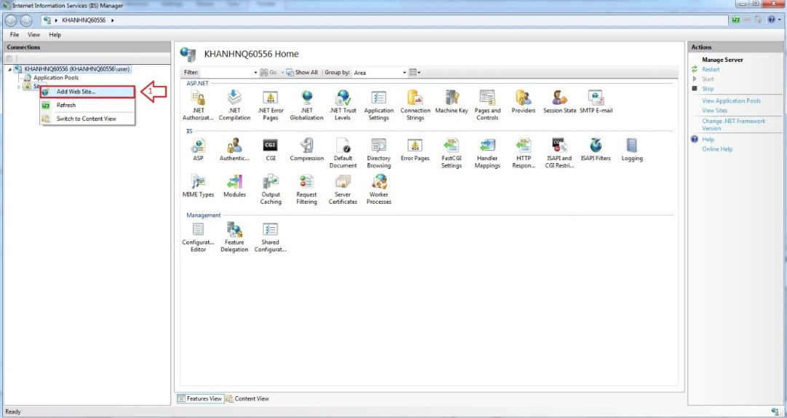

Figure 53: Add Website

* Enter “Site Name”.
* Click “Select” button to select Application pool.

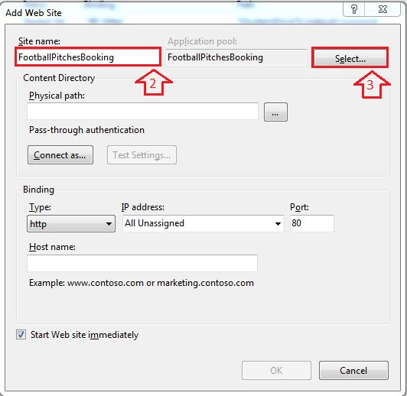

Figure 54: Add Site Name

* Select “ASP.NET v4.0”.

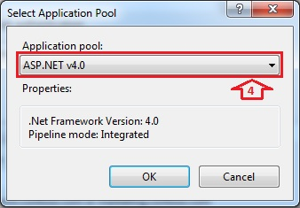

Figure 55: Select ASP.NET

* Browse physical path: “~/ FootballPitchesBooking”.

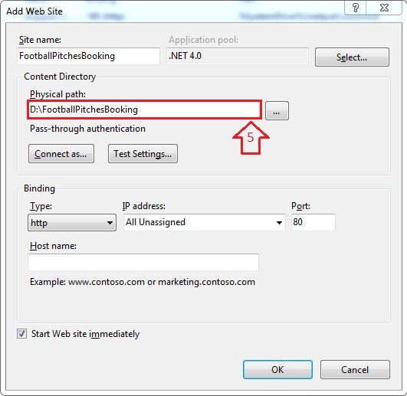

Figure 56: Add Path Link

* Open “~/ FootballPitchesBookingProject/Web.config” file by Notepad.

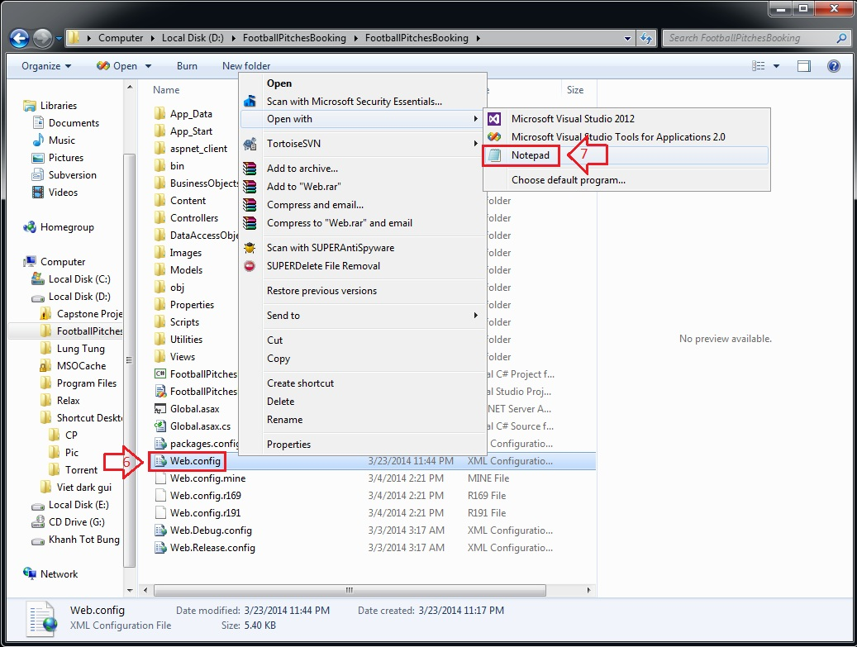

Figure 57: Edit Web.config

* Find “connectionStrings” tag, change “Server Name”, “User ID” and “Password” in its connection string depend on your computer.

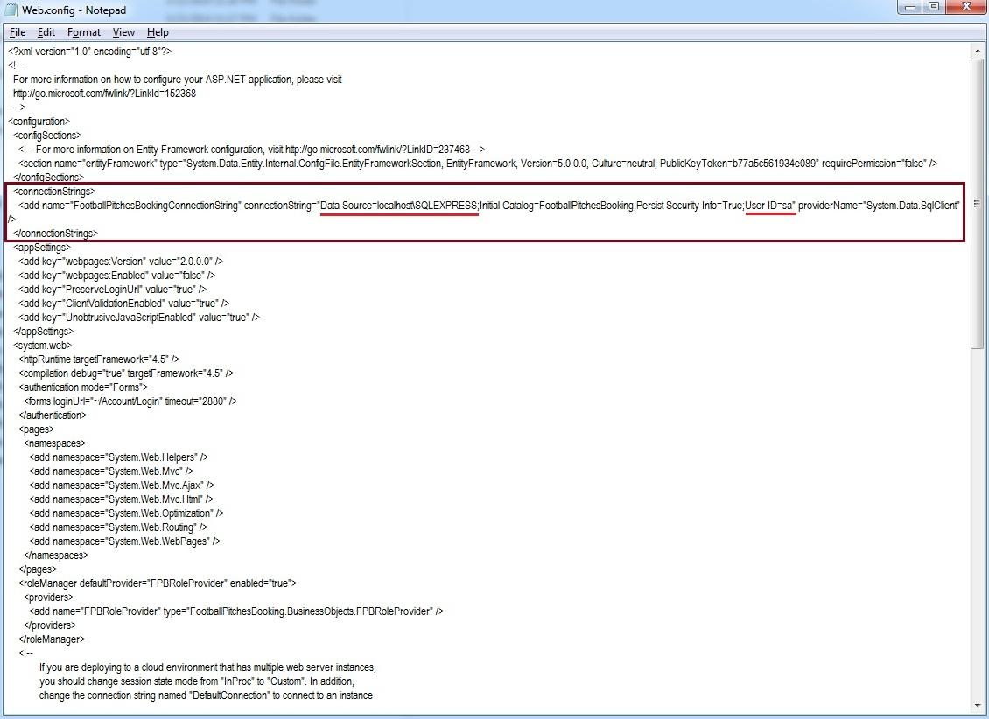

Figure 58: Edit Web.config

* Right Click new site name (FootballPitchesBooking) in left content -> Manage Web Site -> Browse to view the website.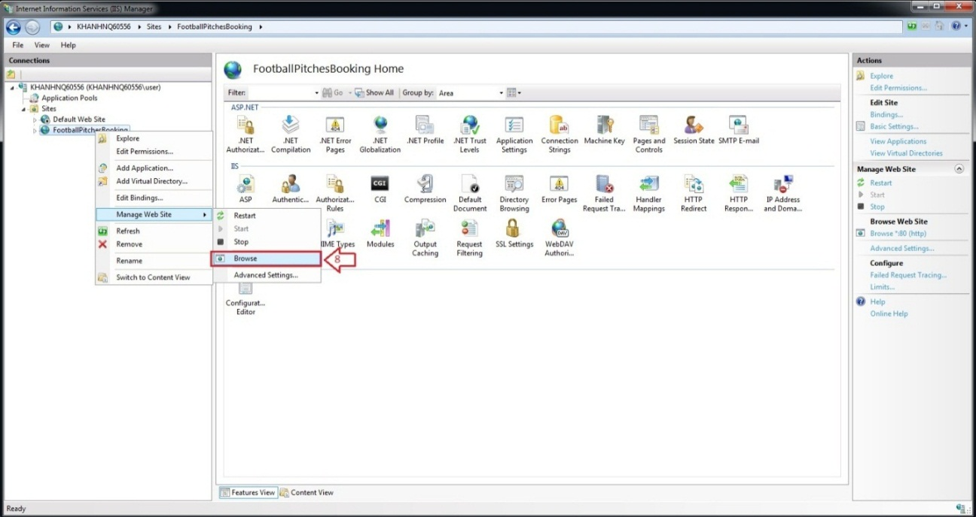

Figure 59: How to open Website

* The website is deployed.

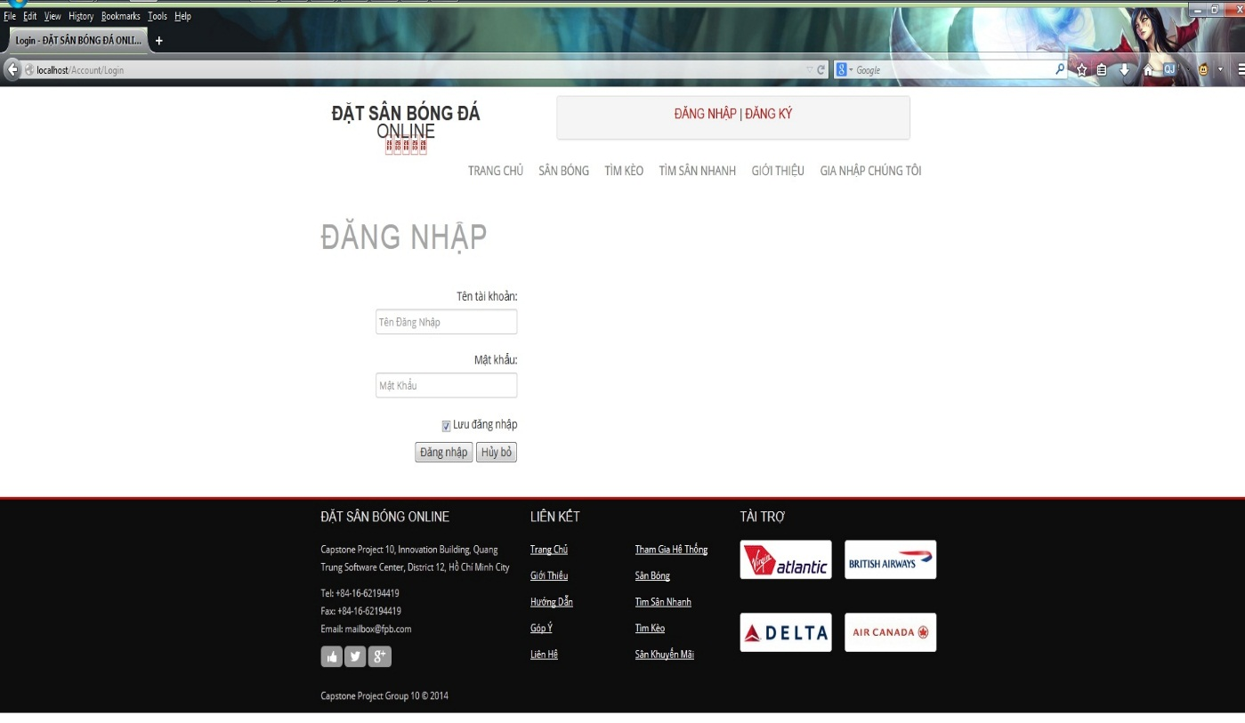

Figure 60: Website is deployed

### User’s Guide

#### Website Master

- Step 1 : Login with WebsiteMaster role

- Step 2 : Click “Quản Trị Website” link in Admin page

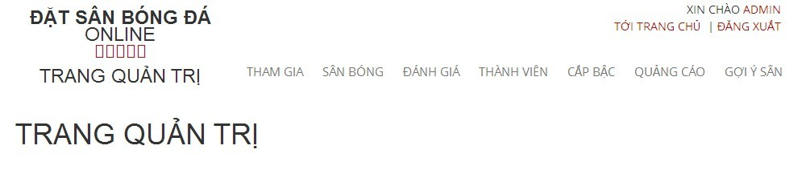

Figure 61: Website Staff

##### Join Request Management

##### View All Join Request

- Step 1 : Click “ Tham Gia “ link to view all join request from member

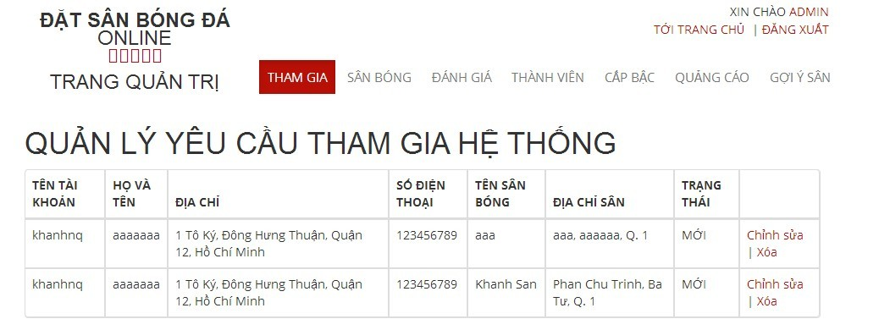

Figure 62: View Join System Requests

##### Stadium Management

###### View All Stadiums

- Step 1 : Click “ Sân Bóng “ link to view all stadiums

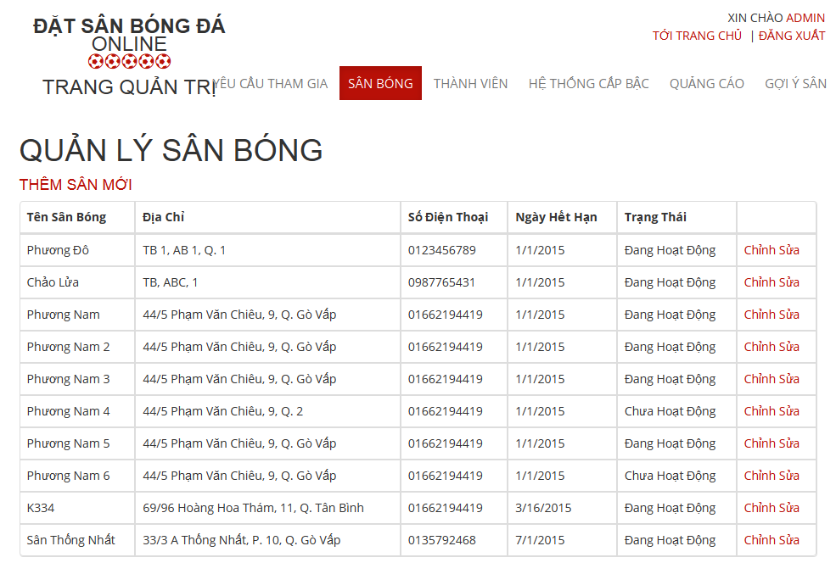

Figure 63: View All Stadiums

###### Add New Stadium

- Step 1 : Click “ Thêm Sân Mới “ link

- Step 2 : Input all required fields

- Step 3 : Click“ Thêm Sân Mới” button to add new stadium or click “ Hủy Bỏ “ button to cancel

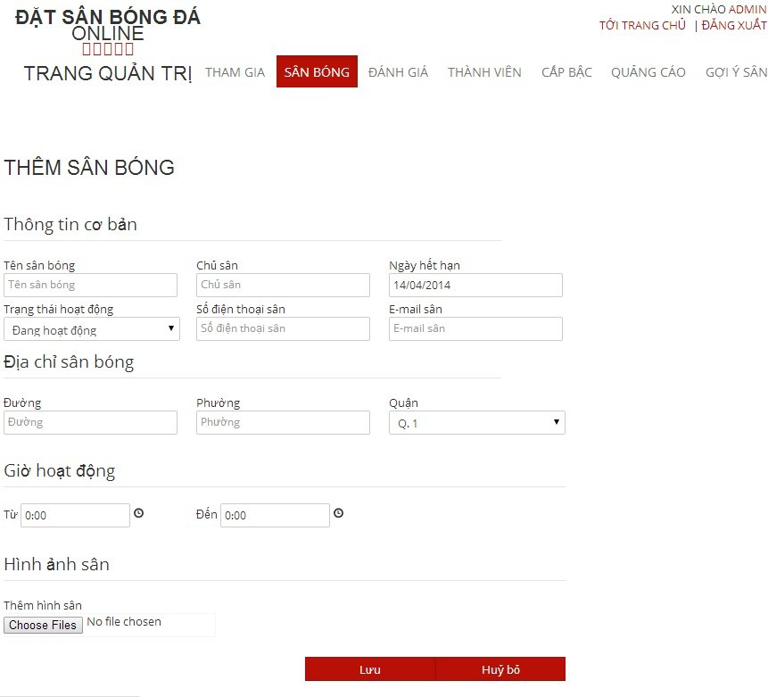

Figure 64: Add New Stadium

###### Edit Stadium

- Step 1 : Click “ Chỉnh Sửa “ link

- Step 2 : Change information of field which you want to change

- Step 3 : : Click“ Lưu” button to save the information of member or click “ Hủy Bỏ “ button to cancel



Figure 65: Edit Stadium

##### User Management

###### View List Members

- Step 1: Choose “ Thành Viên “ link to view all members of the website

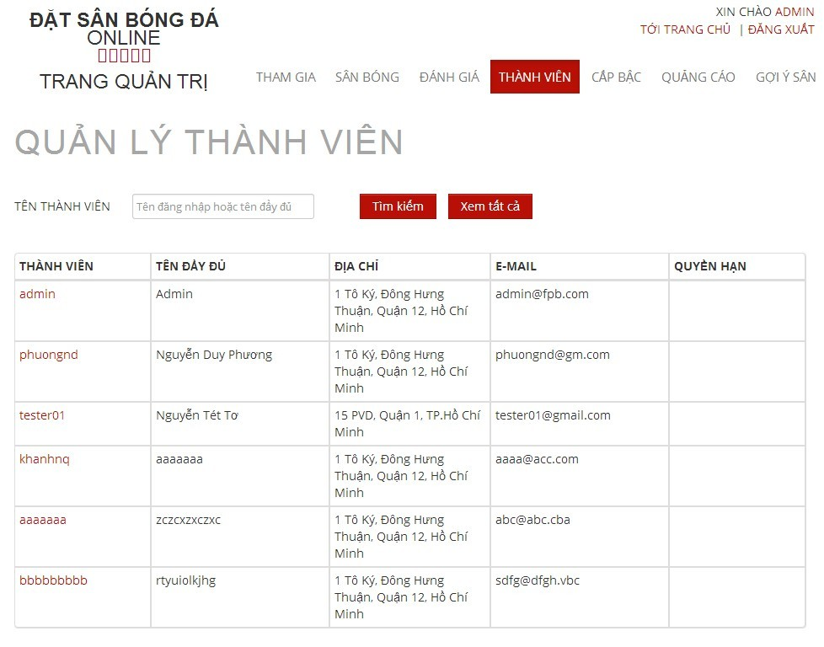

Figure 66: View Add Users

###### Search Members

- Step 1 : Click the textbox beside Search Button in “ Quản Lý Người Sử Dụng “ page

- Step 2 : Input name of member you want to find

- Step 3 : Click“ Tìm Kiếm “ button to find

- Step 4 : Click“ Làm Mới “ to refresh member list.

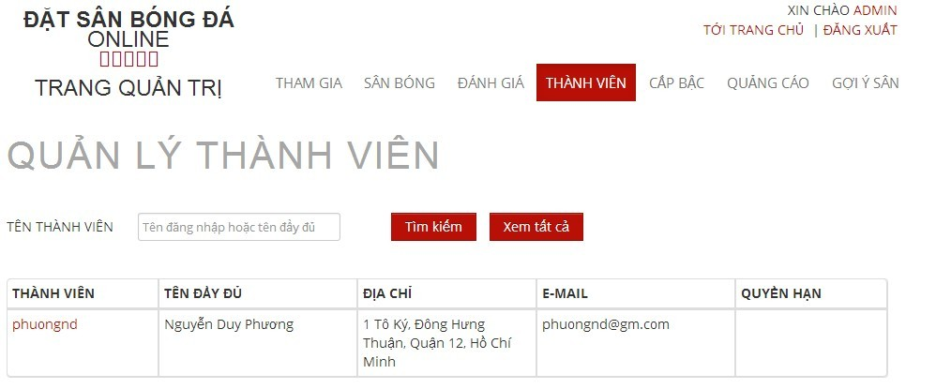

Figure 67: Search User

###### Edit Members

- Step 1 : Click name of the member you want to change information

- Step 2 : Change information of field which you want to change

- Step 3 : Click “ Cập Nhật” button to save the information of member or click “ Hủy Bỏ “ button to cancel

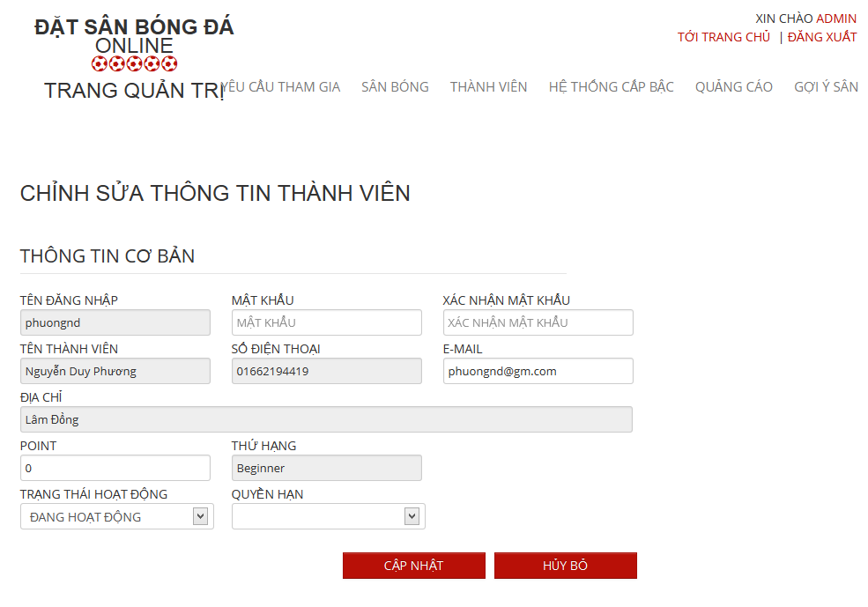

Figure 68: Edit User

##### Recommendation Management

###### View Recommendation Management Page

- Step 1 : Click “ Gợi Ý Sân “ link

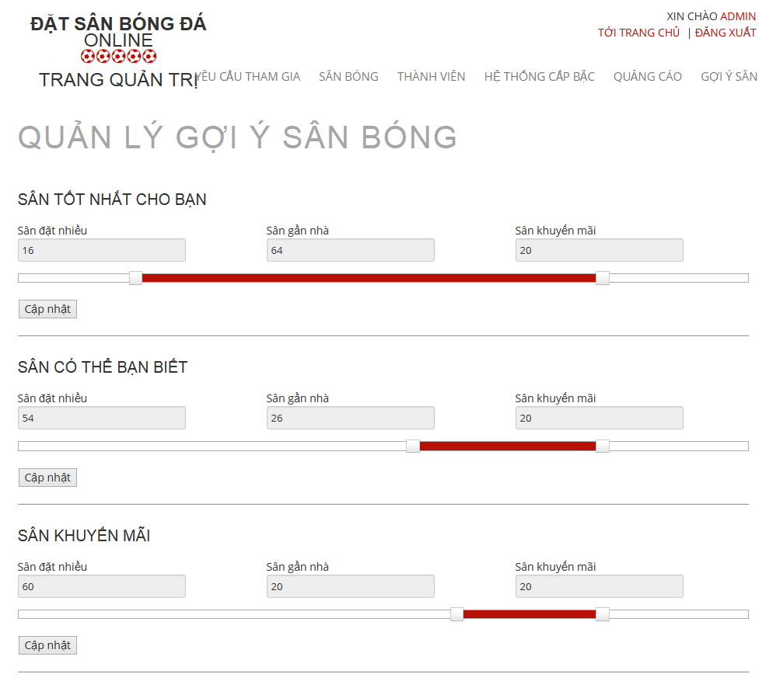

Figure 69: View Recommendation Management

###### Edit in Recommendation Management Page

- Step 1 : Drag on the point to change the value of each priority

- Step 2 : Click “ Cập Nhật “ button to save

#### Website Staff

- Step 1 : Login with WebsiteStaff role

- Step 2 : Click “Quản Trị Website” link

##### User Management

###### View Users List

- Step 1: CLick “ Thành Viên “ link to view all members of the website



Figure 70: View Users List

###### Search User

- Step 1 : Click the textbox beside Search Button in “ Quản Lý Người Sử Dụng “ page

- Step 2 : Input name of member you want to find

- Step 3 : Click“ Tìm Kiếm “ button to find

- Step 4 : Click“ Làm Mới “ to refresh member list.



Figure 71: Search User

###### Edit User

- Step 1 : Click name of the member who you want to change information

- Step 2 : Change information of field which you want to change

- Step 3 : Click “ Cập Nhật” button to save the information of member or click “ Hủy Bỏ “ button to cancel



Figure 72: Edit User

#### Stadium Staff

- Step 1 : Login with Stadium Staff role

- Step 2 : Click “Quản Lý Sân Bóng ” link

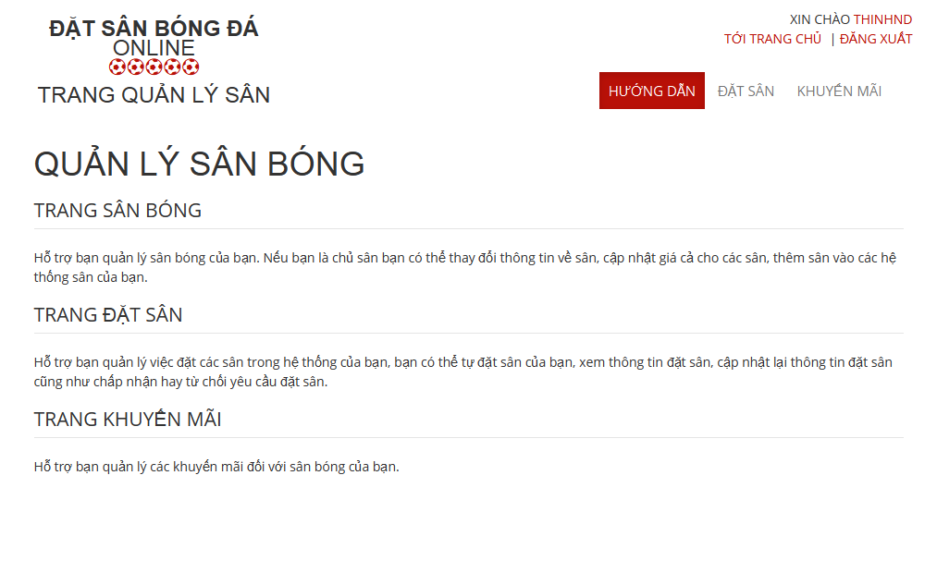

Figure 73: Stadium Management

##### Reservation Management

###### View All Reservations

- Step 1 : Click “ Đặt Sân “ link to view all reservations

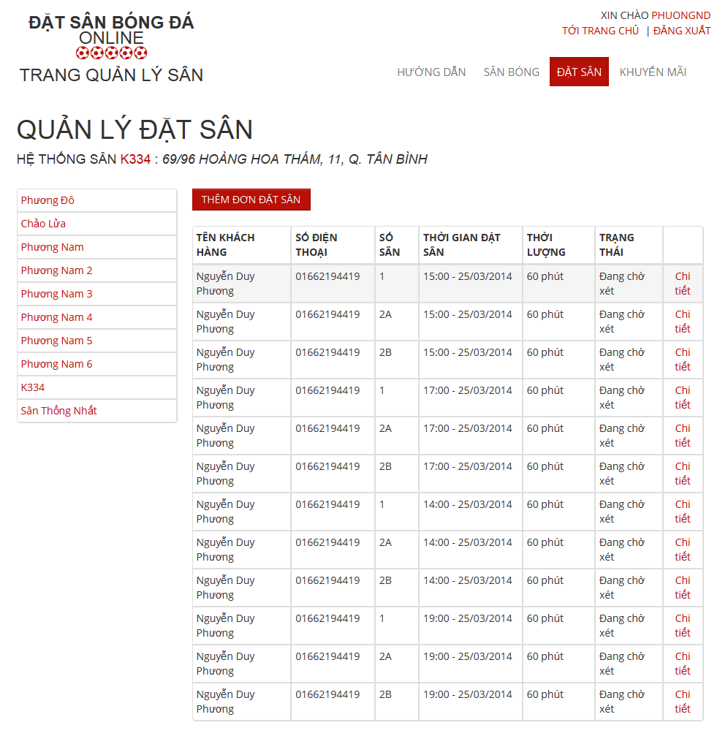

Figure 74: View Reservations

###### Create Reservation

- Step 1 : Click “ Thêm Đơn Đặt Sân “ button in “ Quản Lý Đặt Sân “ page

- Step 2: Input in all required fields

- Step 3: Click “ Lưu” button to add new price list or click “ Hủy Bỏ “ button to cancel

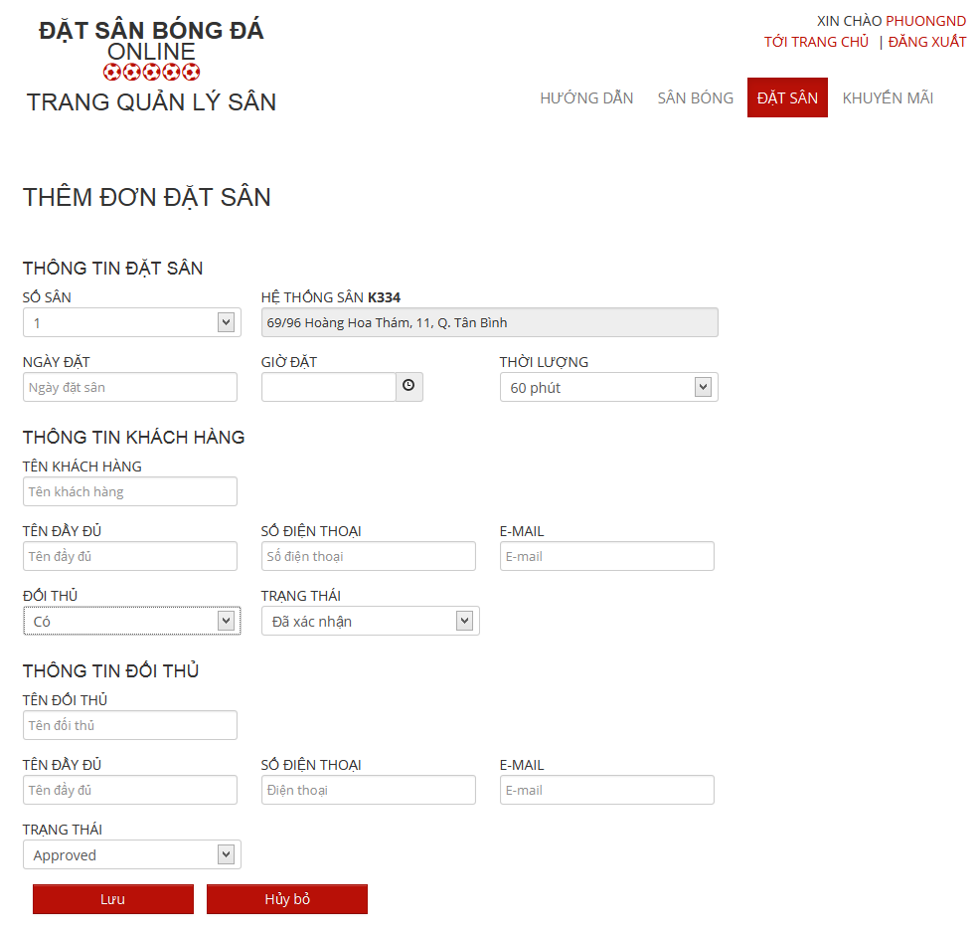

Figure 75: Create Reservation

###### Confirm Reservation

- Step 1 : Click “ Chi tiết “ link of the reservation which you want to examine

- Step 2 : Click “Xác Nhận” button to confirm or Click “Từ Chối” to deny or Click “ Chỉnh Sửa “ to edit reservation or Click “ Quay Lại “ to cancel

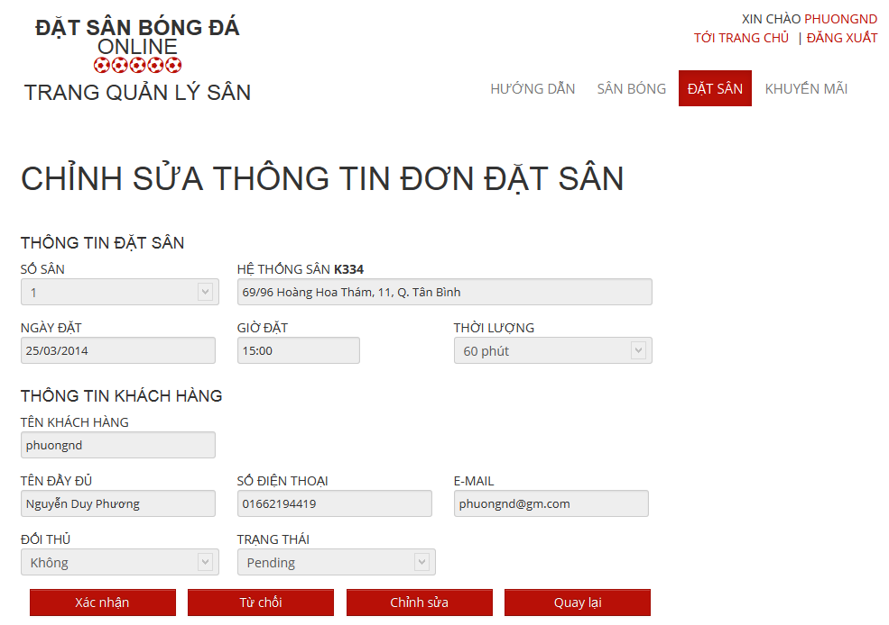

Figure 76: Confirm Reservation

###### Edit Reservation

- Step 1 : Click “ Chỉnh Sửa “ button to edit reservation which you want to change

- Step 2: Change information about that reservation

- Step 3: Click “Lưu” button to save or click “Hủy bỏ” to cancel

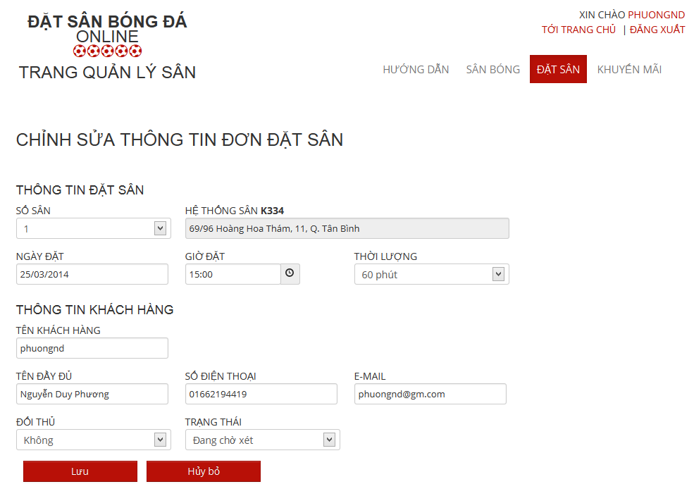

Figure 77: Edit Reservation

#### Stadium Owner

- Step 1 : Login with StadiumOwner role

- Step 2 : Click “Quản Trị Sân Bóng” link

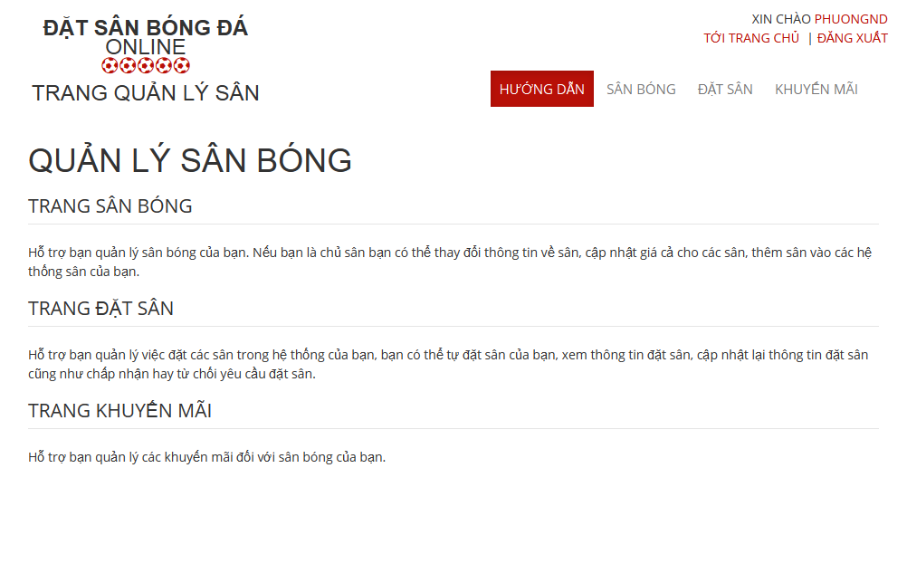

Figure 78: Stadium Management

##### Stadium Management

###### View All Stadiums

-Step 1 : Click “ Sân Bóng “ link

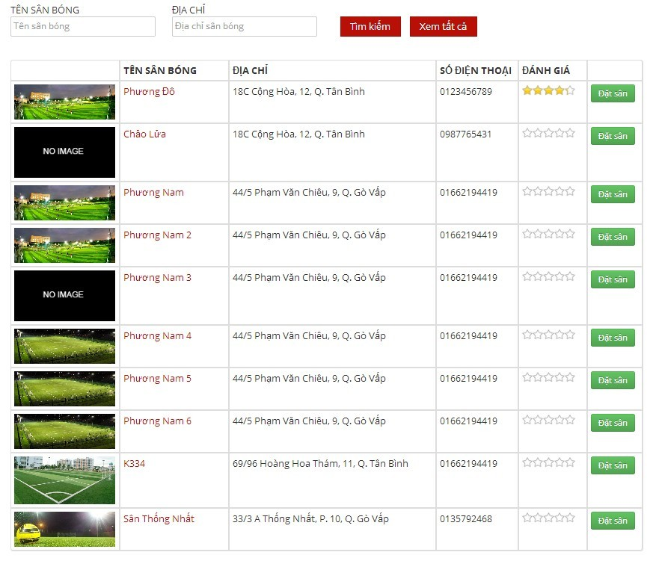

Figure 79: View Stadiums

###### Edit Stadium

- Step 1 : Click “ Chỉnh sửa “ link of the stadium which you want to change

- Step 2 : Change information of field which you want to change

- Step 3 : Click “ Chọn Hình Ảnh “ button to choose new image about this stadium

- Step 4 : Click “Lưu ” button to save or click “Hủy bỏ” to cancel

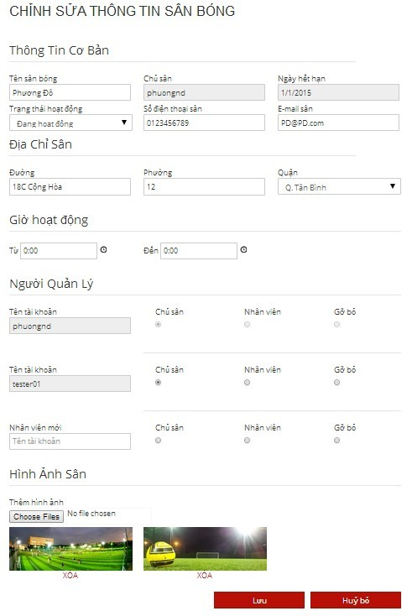

Figure 80: Edit Stadium

###### View Child Fields

- Step 1 : Click “ Sân Con “ link to see all child fields of this stadium

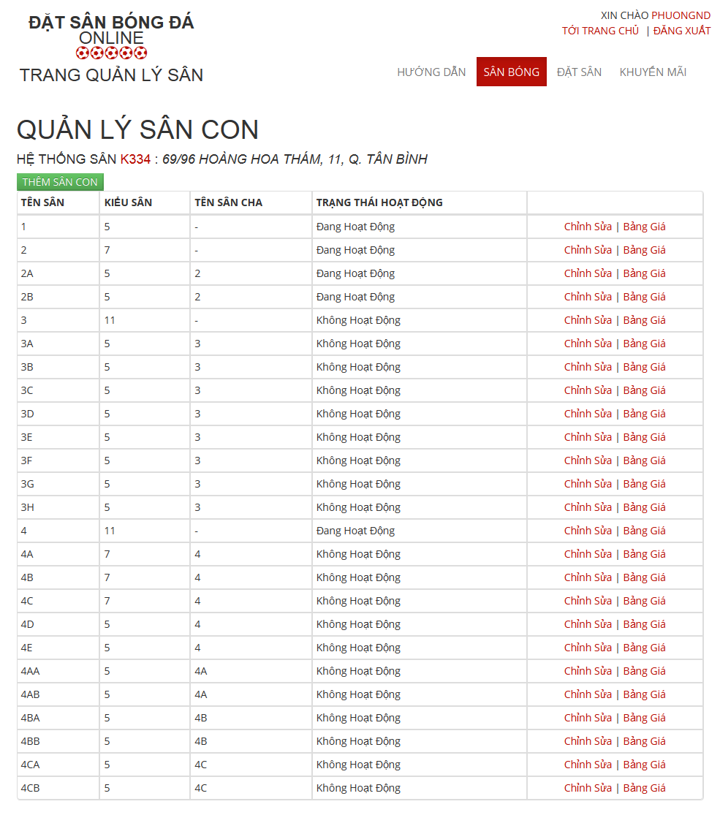

Figure 81: View Child Fields

###### Add New Child Field

- Step 1 : Click “ Thêm Sân Con “ button in “ Quản Lý Sân Con “ Page

- Step 2: Input in all required fields

- Step 3: Click “ Lưu” button to add new child field or click “ Hủy Bỏ “ button to cancel

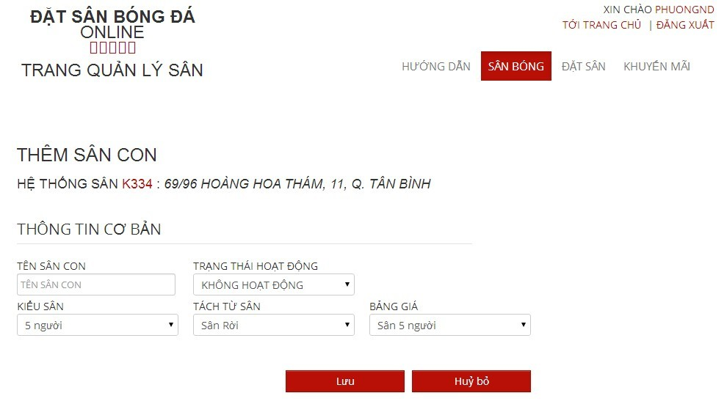

Figure 82: Add Child Field

###### Edit Child Field

- Step 1 : Click “ Chỉnh sửa “ link of the child field which you want to change

- Step 2 : Change information of field which you want to change

- Step 3 : Click “Lưu” button to save or click “Hủy bỏ” to cancel

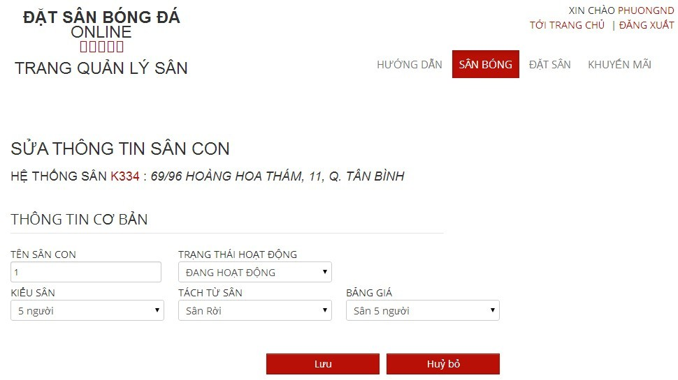

Figure 83: Edit Child Field

###### View Price List of Child Filed

- Step 1 : Click “ Bảng Giá “ link of the child field which you want to see

###### View Price List

- Step 1 : Click “ Bảng Giá “ link to see all child fields of this stadium

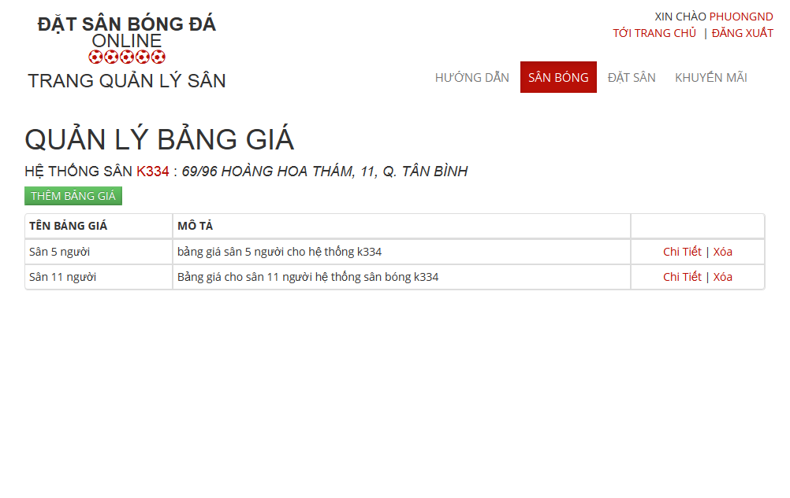

Figure 84: View Child Fields

###### Add Price Table

- Step 1 : Click “ Thêm Bảng Giá “ button in “ Quản Lý Bảng Giá“ Page

- Step 2: Input in all required fields

- Step 3: Click “ Lưu” button to add new price list or click “ Hủy Bỏ “ button to cancel

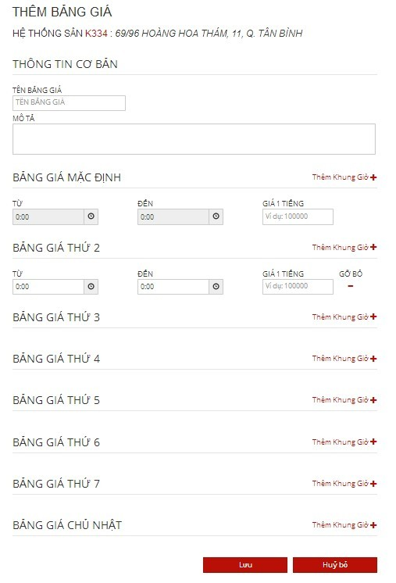

Figure 85: Add Price Table

##### Promotion Management

###### View Promotions List

- Step 1: Click “Khuyến mãi” link in “ Quản lý sân “ page

- Step 2: Choose Stadium to view promotions of that stadium

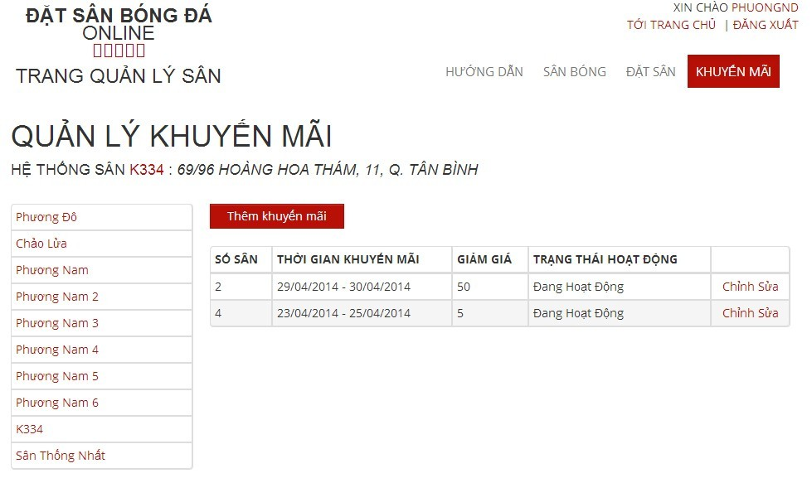

Figure 86: View Promotions List

###### Add New Promotion

- Step 1: Click “Thêm khuyến mãi” button from “ Thêm khuyến mãi “page

- Step 2: Input information about promotion

- Step 3: Click “Lưu” button to save or click “Hủy bỏ” to cancel

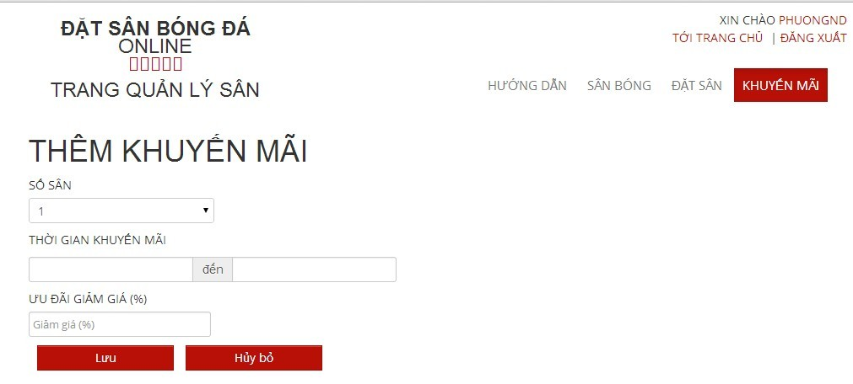

Figure 87: Create Promotion

###### Edit Promotion

- Step 1: Click “Chỉnh sửa” link on which promotion you want to edit

- Step 2: Change information about that promotion

- Step 3: Click “Lưu” button to save or click “Hủy bỏ” to cancel

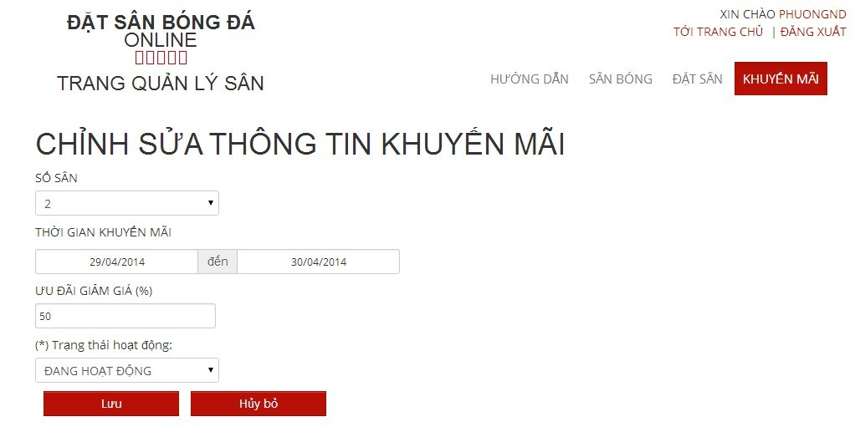

Figure 88: Edit Promotion

##### Reservation Management

###### View All Reservations :

- Step 1 : Click “ Đặt Sân “ link to view all reservations



Figure 89: View Reservations

###### Add New Reservation

- Step 1 : Click “ Thêm Đơn Đặt Sân “ button in “ Quản Lý Đặt Sân “ page

- Step 2: Input in all required fields

- Step 3: Click “ Lưu” button to add new price list or click “ Hủy Bỏ “ button to cancel



Figure 90: Create Reservation

###### Confirm Reservation

- Step 1 : Click “ Chi tiết “ link of the reservation which you want to examine

- Step 2 : Click “Xác Nhận” button to confirm or Click “Từ Chối” to deny or Click “ Chỉnh Sửa “ to edit reservation or Click “ Quay Lại “ to cancel



Figure 91: Confirm Reservation

###### Edit Reservation

- Step 1 : Click “ Chỉnh Sửa “ button to edit reservation which you want to change

- Step 2: Change information about that reservation

- Step 3: Click “Lưu” button to save or click “Hủy bỏ” to cancel



Figure 92: Edit Reservation

#### Member

##### Find Available Stadium

- Step 1: Click “Tìm sân nhanh” link or open “Tìm sân nhanh” drop down list at “ Trang chủ “ page

- Step 2: Choose information

- Step 3: Click “Tìm kiếm” button to find available stadium

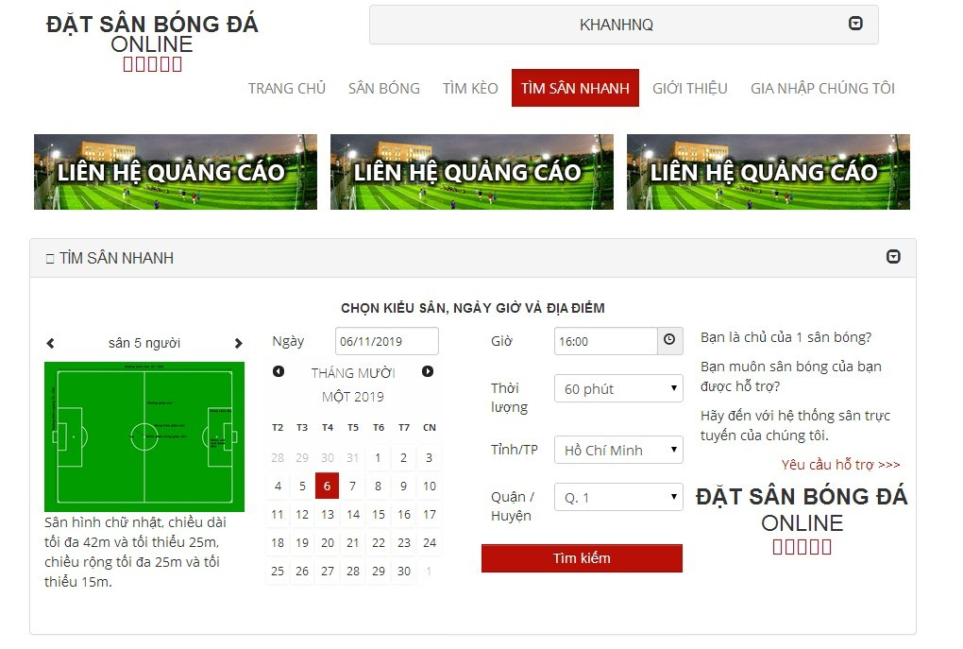

Figure 93: Find Available Stadium

##### Find Stadium

- Step 1 : Click “ Sân bóng “ link in “ Trang chủ “ page

- Step 2 : Input all information about the stadium you want to find

- Step 3 : Click “ Tìm Kiếm “ button to find

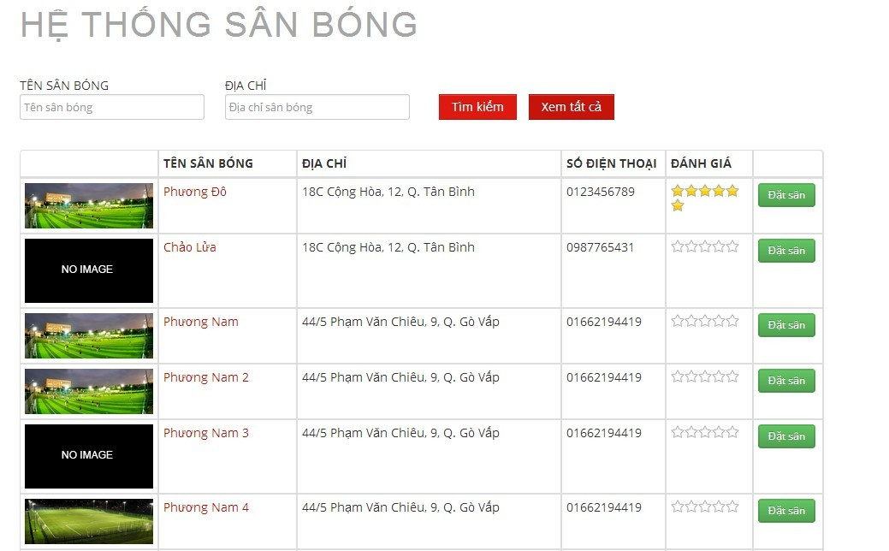

Figure 94: Find Stadium

##### Book Field

- Step 1 : Click “ Sân Bóng “ link in Homepage

- Step 2 : Click “ Đặt Sân “ button on the stadium you want to book or Click the stadium which you want to book and Click “ Đặt Sân “ button

- Step 3 : Input all require information about stadium you want to book

- Step 4 : Click “ Đặt Sân “ button to book stadium or “ Hủy Bỏ “ button to cancel or “ Lưu “ button to edit “ Thông Tin Cập Nhật “

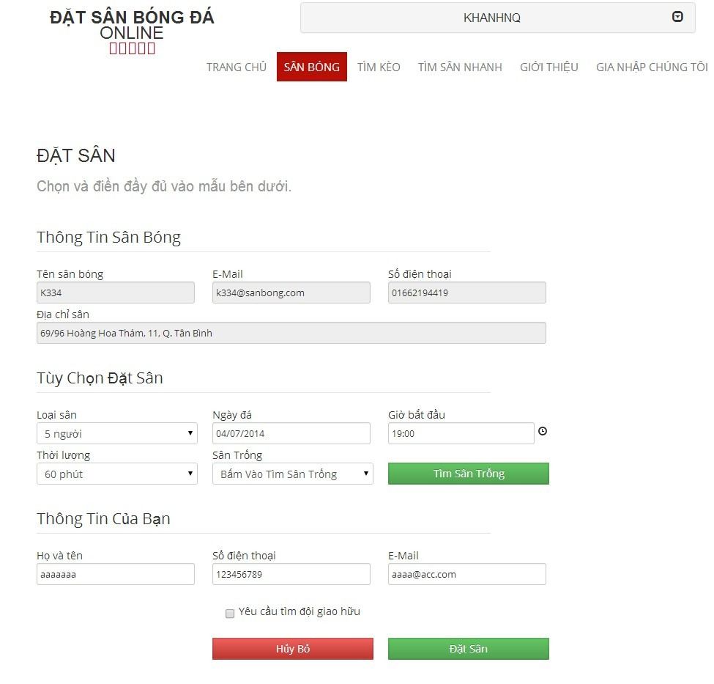

Figure 95: Book Field

##### Request Join System

- Step 1: Click “Gia nhập chúng tôi” link from home page

- Step 2: Input all require information

- Step 3: Click “Gửi yêu cầu” link to send this request or click “Trang chủ” link to back to home page

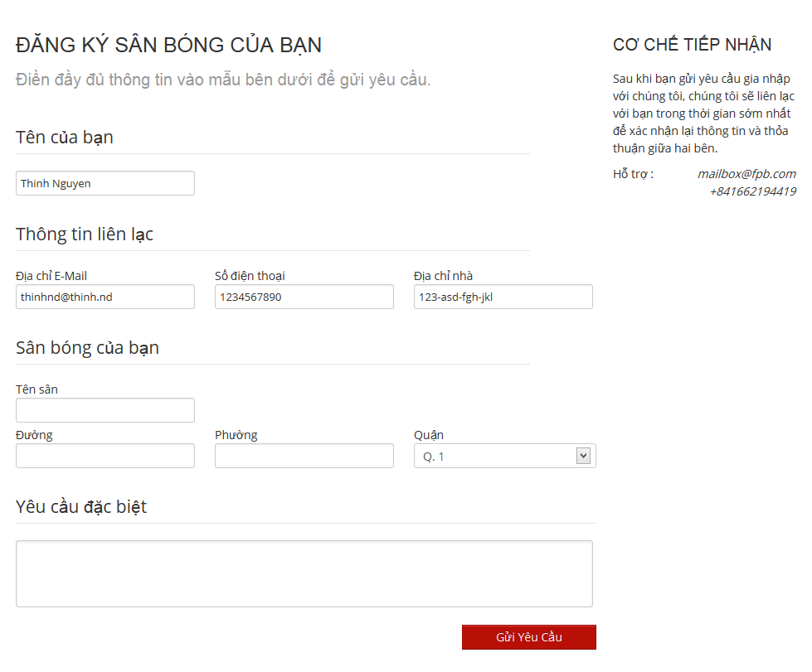

Figure 96: Request Join System

##### Join Rival

- Step 1 : Click “ Sân bóng “ link on “ Trang chủ “ page

- Step 2 : Click " Đặt Sân " button in one stadium in list stadium or lick on one stadium and click “ Đặt sân “ button

- Step 3 : Input all information

- Step 4 : Check on “ Yêu cầu tìm đội giao hữu “ drop down list

- Step 5 : Click “ Đặt sân “ button

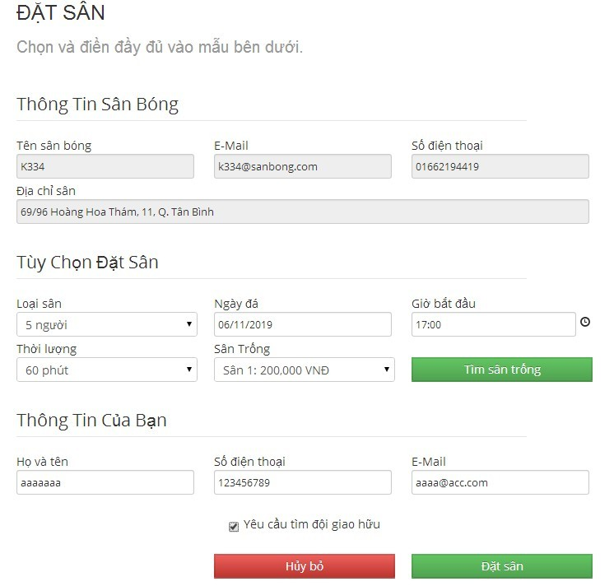

Figure 97: Join Rival

#### Reference Guide:

The following User guides are reference to: CD\reports\Report6.docx

**Website Master:**

* View Ranks List
* Create Rank
* Edit Rank
* Delete Ranks

**Website Staff:**

* View All Advertises
* Add New Advertises

**Stadium Staff:**

* View List Promotions
* Add New Promotion
* Edit Promotion

**Member:**

* Register
* Login
* View Account Profiles
* Edit Account Profiles
* View Stadium Details
* Rate Stadium
* Review Stadium
* Cancel Reservation
* Find Rival
* View Booking History
* ForgotPassword
* Resend mail to activate Account
* FeedbackWebsite

#### Other [Optional]